AXOOM Gate

Configuration Guide

For

The Rules Engine plugin (149)

For plugin version 4.104.0

October 15, 2018

Table of Contents

Chapter 1 Introduction to AXOOM Gate Plugins 4

1.1 Overview 4

1.2 About AXOOM Gate 4

1.3 About Plugins 4

1.4 Plugin Deployment Patterns 5

1.5 The Plugin Dashboard 5

Chapter 2 The Rules Engine Plugin 7

2.1 About the Rules Engine Plugin 7

2.2 Login to AXOOM Gate 7

2.3 Accessing the plugin dashboard 9

2.4 Viewing Existing Rules 9

Chapter 3 Configuration Settings 11

3.1 Rule Status Settings 11

3.2 Trigger Object Settings 12

3.3 Action Settings 13

3.4 Thing/Property Action settings 13

3.5 TSM Action Settings 14

3.6 Example of Using the Rules Engine 15

Chapter 4 Setting up the Machine Environment 16

4.1 Create Countdown Timer for Machine M1 16

4.2 Create Countdown Timers for Machine 2 (M2) and Machine 3 (M3) 19

Chapter 5 Example: Setting Up Rule #1 20

5.1 Step One: Define the rule 20

5.2 Step Two: Define Trigger Object 21

5.3 Step Three: Set Action Object 21

5.4 Testing Rule #1 22

Chapter 6 Example: Setting Up Rule #2 29

6.1 Rules Registry Dashboard 29

6.2 Creating a new rule 30

6.3 Testing Rule 2 31

Chapter 7 Example: Setting Up Rule #3 32

7.1 Create Rule 3 32

7.2 Testing Rule 3 33

Appendix A: AXOOM Gate Navigation Icons 35

Appendix B: System Log Messages for The Rules Engine 36

Appendix C: Messaging Plugin Configuration 37

# Introduction to AXOOM Gate Plugins

## Overview

This document covers configuring the Rules Engine plugin running in AXOOM Gate (and compatible platforms).

Note: This configuration guide assumes these plugins are running:

* Rules Engine plugin
* Messaging plugin
* Virtual Things plugin

## About AXOOM Gate

AXOOM Gate provides remote and mobile access to industrial production equipment in a secure, efficient, extensible manner. In the interest of operational efficiency and reduced complexity, industrial systems are often configured with data security features disabled. With its built-in, IT-friendly data security settings, AXOOM Gate seamlessly links production systems with office and mobile systems without compromising either factory operation or IT data security requirements.

The installation folder for AXOOM Gate in Microsoft Windows is: C:\Program Files (x86)\AXOOM\AXOOM-Gate. The main executable program is AxoomGateService.exe, which can run both as a Windows service (akin to a Linux daemon) as well as a command-line program.

## About Plugins

An AXOOM Gate plugin is a dynamic-link library (DLL) built with the C-Labs™ C-DEngine™ SDK. Plugins must have a filename with a prefix of CDMy or C-DMy (examples: CDMyCharts.dll and C‑DMyNetwork.dll).

Plugins enable custom features in AXOOM Gate. The many types of plugins include:

* Configuration Plugins – provide a user interface for configuring hardware or software.
* Connector Plugins – enable a communication channel between AXOOM Gate nodes.
* Device Plugins – enable connections to and data collection from local sensors and devices directly connected to the system running AXOOM Gate.
* User Interface (NMI) Extension Plugins – provide custom controls and other user interface extensions to AXOOM Gate.
* Protocol Plugins – support industry standard protocols like OPC / UA, Modbus, MT Connect, serial ports, and proprietary programmable logic controllers (PLCs) such as the Siemens S7.
* Service Plugins – support other plugins.

As of this writing, there are over 100 plugins. AXOOM Gate v2.109 ships with 14 plugins. Most of these plugins exist to enable live capture of one or more data points from a running system. Such data capture plugins all share a common pattern in terms of how they are configured.

## Plugin Deployment Patterns

To simplify the proper plugin deployment and configuration, this deployment pattern applies to almost every AXOOM Gate plugin:

1. Secure login – A username and password are required to log into AXOOM Gate.
2. Plugin button on home page – All plugins have a button on the AXOOM Gate home page, the first page displayed when you log into AXOOM Gate (see Figure 2.3). Click the plugin’s button to access the plugin dashboard.
3. Plugin dashboard – A plugin dashboard displays all configured items (connections, object, devices, sensors). A plugin dashboard also has a button for creating new items (see Figure 1.1).
4. Editing existing items – Configuring connections involves setting network or device addresses.
5. Once connections are established, you pick specific data points – also known as “properties” – to read.
6. Such properties are grouped together as “Things,” such as you might expect to find in a package that was created to help connect to the “Internet of Things.”

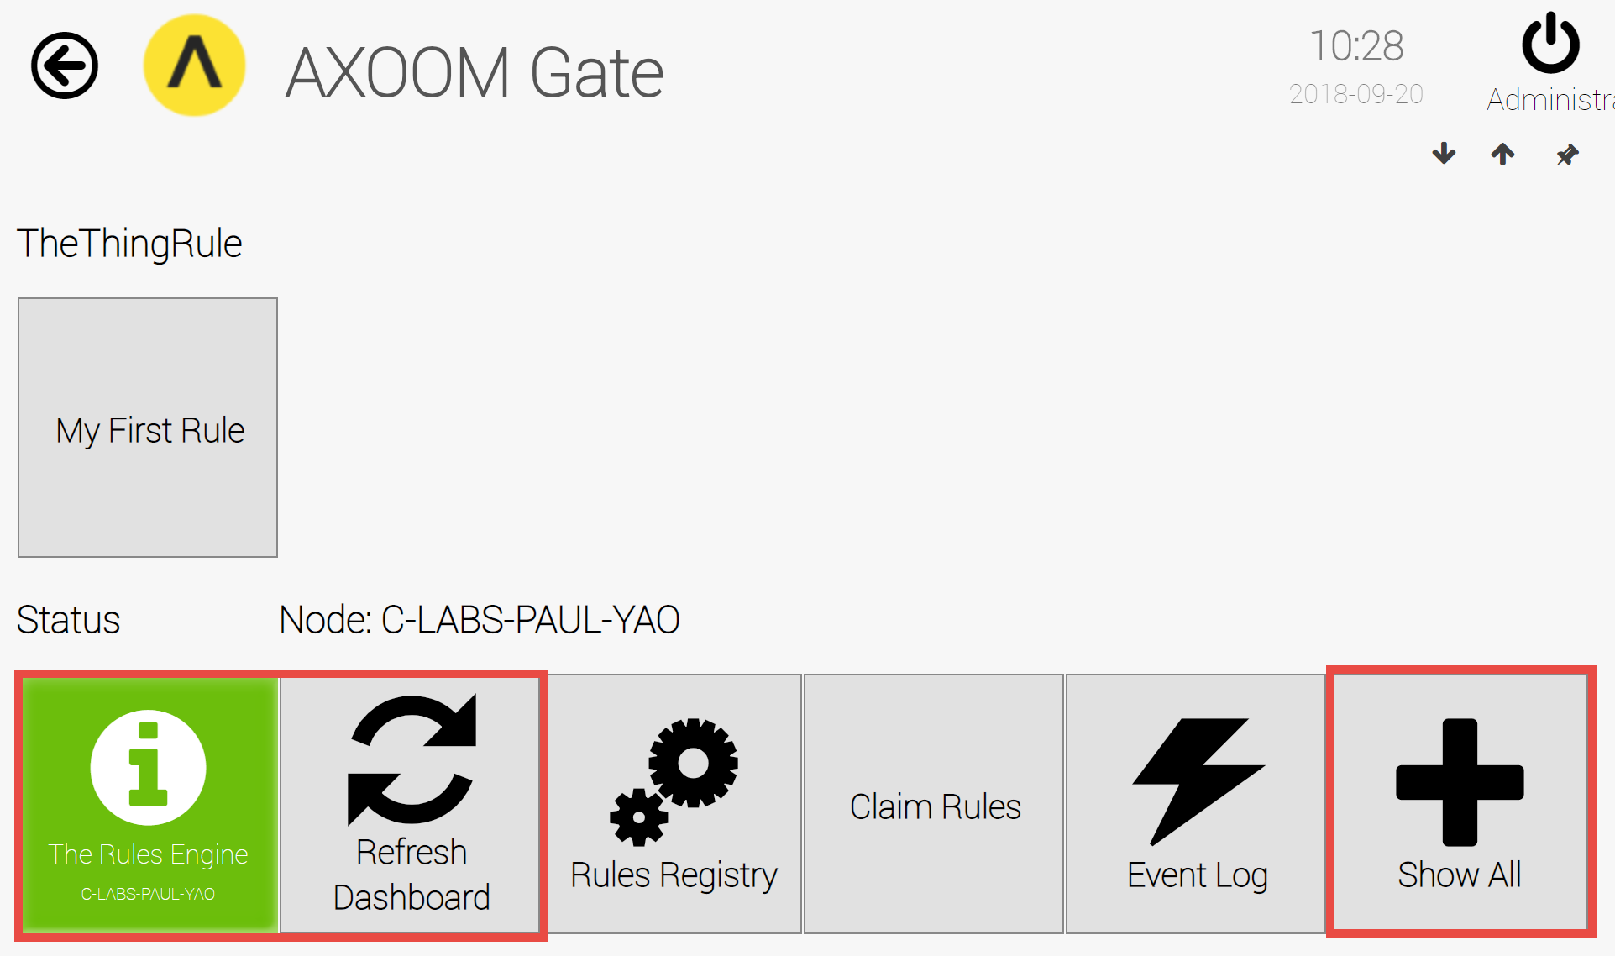  
**Figure 1.1. The Rules Engine plugin dashboard.**

## The Plugin Dashboard

A plugin’s dashboard (see Figure 1.1) provides the primary plugin interface. All “live” items appear at the top of a plugin dashboard. A series of buttons appears at the bottom of the plugin dashboard. In the dashboard shown in Figure 1.1, red rectangles identify the three standard dashboard buttons:

1) About button: The button with the circled “i” is the About button. Click for details on the dashboard. The button color reflects the status. Status colors, associated status code, and meaning of the status, are summarized here:

* + Gray (0): Idle.
  + Green (1): Active / Ok.
  + Yellow (2): Warning.
  + Red (3): Error.
  + Blue (4): Starting / Setup / Ramp Up.
  + Brown (5): Design / Engineering / Configuration.
  + Purple (6): Shutdown.
  + Black (7): Unknown / Unreachable.

2) Refresh Dashboard button: Reloads the dashboard with latest values.

3) Show All button: Open all forms and tables associated with the plugin.

Figure 1.2 shows the default image of a table button. Click a table button to view and edit a table of items managed by the plugin. For example, you can add new items, edit existing item properties, or delete items.

  
**Figure 1.2. Buttons with this table icon enable viewing and editing tables of plugin items.**

In the rules engine, another icon (see Figure 1.3) serves to provide a table of available rules.

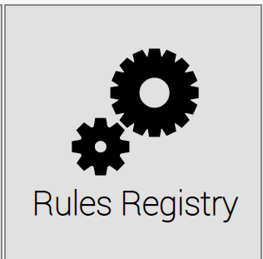

**Figure 1.3. Click this button to view and edit the current rules in the Rules Engine plugin.**

# The Rules Engine Plugin

This chapter introduces the Rules Engine plugin, and covers the steps needed to create new rules.

## About the Rules Engine Plugin

The Rules Engine plugin allows you to define actions that result from changes to a trigger object. One common use for rules are to send notifications after a specified condition has been met. For example, when the temperature rises over 80 degrees Celsius. After a condition has been met, then an action is performed on another object, known as the action object. For example, If the status level increases on a Thing, then a message can be sent out to a predefined destination. The three parts to a rule – and the three things that need to be configured – are as follows:

* A trigger object – is an object with specific property values that are being monitored to reach a specific condition.
* An action – is a response taken when the condition on the trigger object is met.
* An action object – is the target of the action that is taken.

## Login to AXOOM Gate

Enter this URL, <http://localhost:8701/nmi>, in a web browser. The following login page appears:

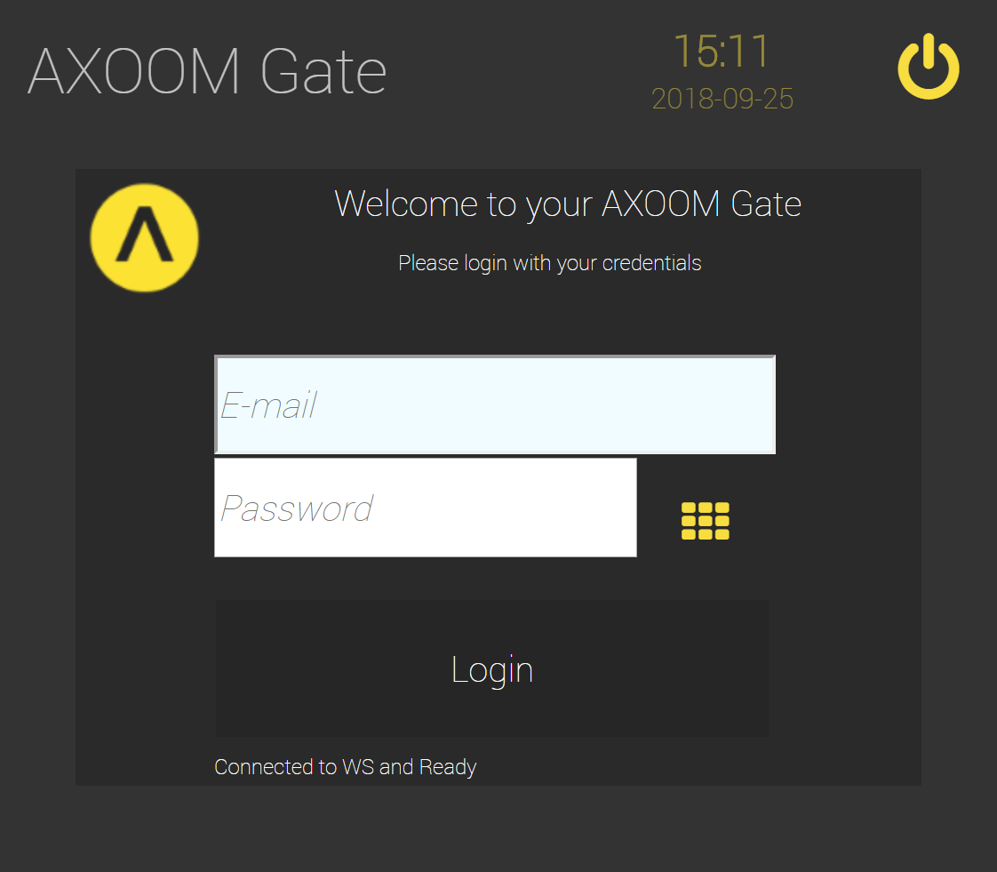  
**Figure 2.1. The dark scheme for the AXOOM Gate login page.**

This URL, <http://localhost:8701/lnmi>, enables the “light” display scheme:

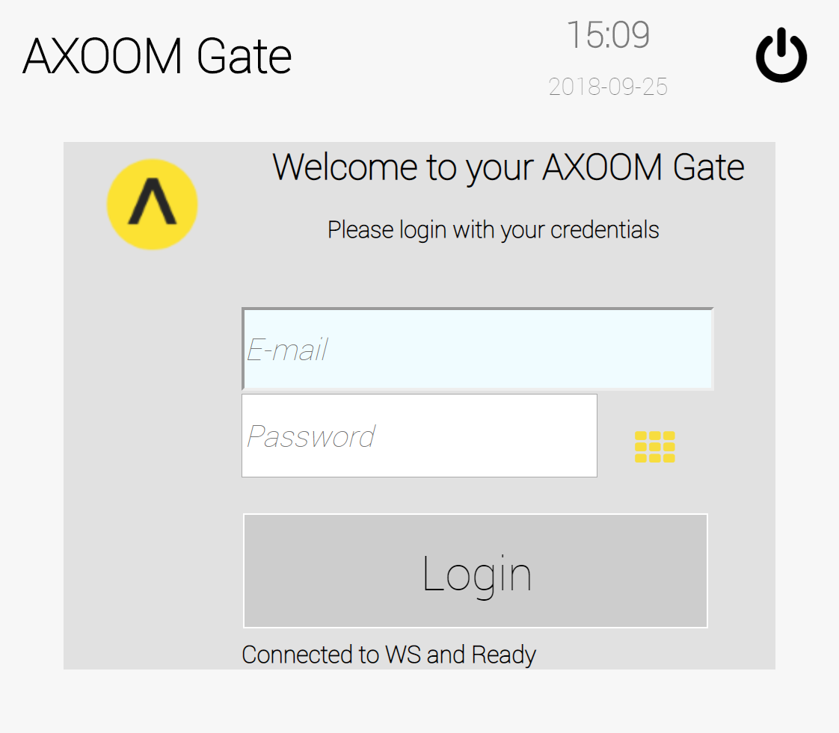  
**Figure 2.2. The light scheme for the AXOOM Gate login page.**

You see the AXOOM Gate home page, as shown in Figure 2.3.

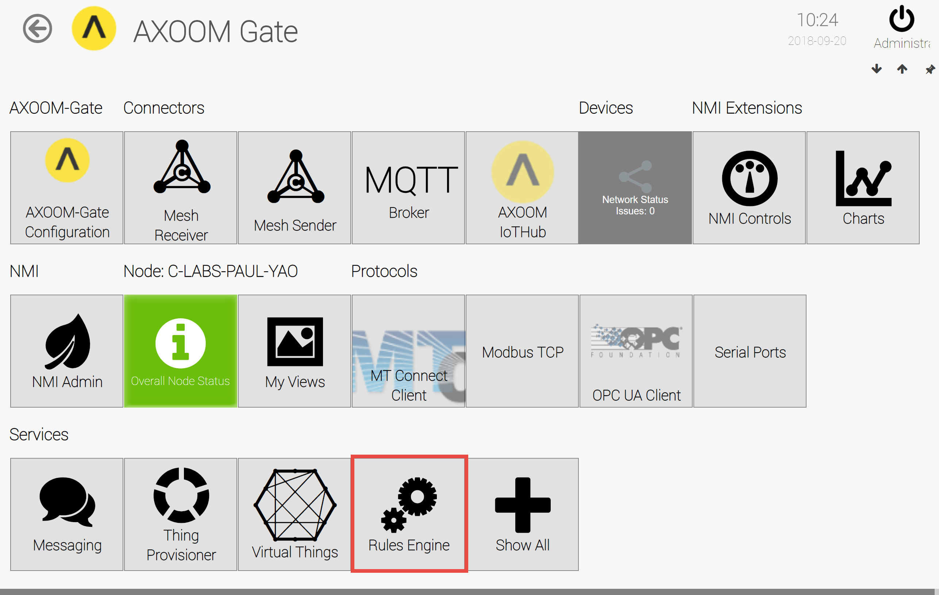  
**Figure 2.3. The “Rules Engine” plugin button highlighted on the AXOOM Gate home page.**

## Accessing the plugin dashboard

When you click the Rules Engine plugin button, the plugin dashboard appears (see Figure 2.4).

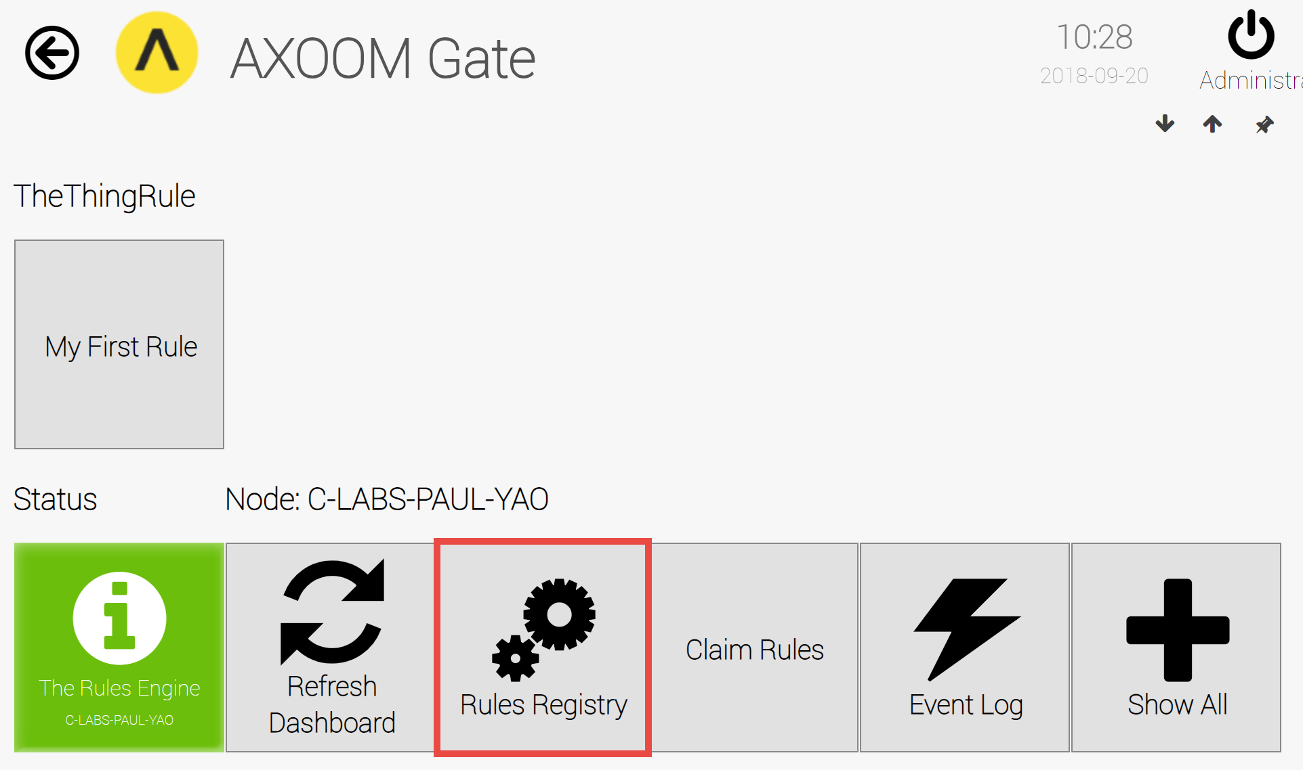  
**Figure 2.4. The Rules Engine Plugin dashboard.**

Rules are stored in the Rules Registry. Click the Rules Registry button for current rules.

## Viewing Existing Rules

The Rules Registry is populated with “My First Rule” (see Figure 2.5). Click the properties icon () to see the current settings. (Click the Refresh ()button for all current rules.)

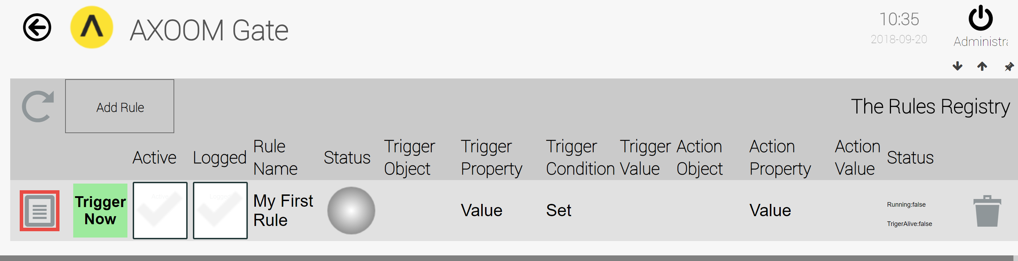 **Figure 2.5. Click the properties icon to view details about the rule.**

The settings page for the rule appears (see Figure 2.6), with six settings groups:

1. Rule Status settings
2. Rule Configuration settings
3. Trigger Object settings
4. Action Settings
5. Thing / Property Action settings
6. TSM Action settings

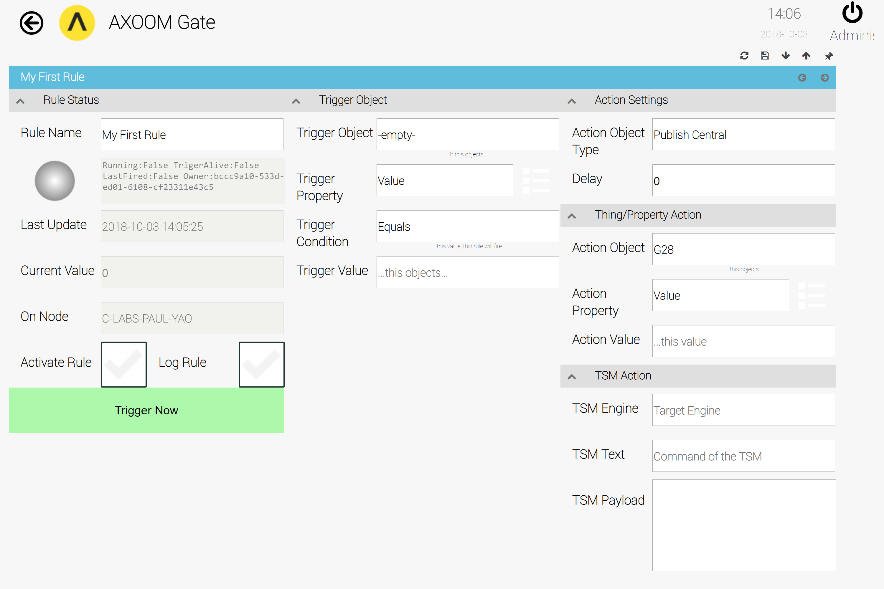  
**Figure 2.6 Settings page for rules, with all settings groups showing.**

# Configuration Settings

## Rule Status Settings

Basic rule information can be found in the first setting group, the Rule Status settings (see Figure 3.1). It displays rule’s properties such as: rule name, status, update info, current value and the owner node of the rule.

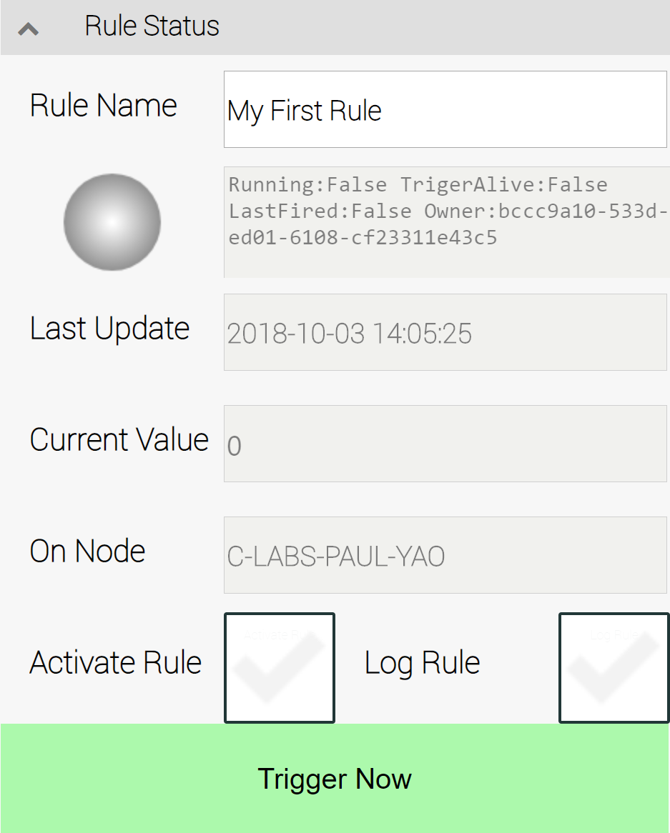  
**Figure 3.1. Settings for Rules Status**

**Rule Name**:The friendly name of the rule, an editable text field.

**Status Light and last message text field**:

Last Message Field: Displays last message.

Status Light: represents state of a rule, as described in this table:

| **Status Light Color** | **Status Description** |
| --- | --- |
| Gray | Rule is inactive. |
| Green | Rule is active |

**Last Update**: Displays date and time of the last update of the rule.

**Current Value**: Displays value of the rule (where applicable)

**On Node**: Displays the name of the node on which the plugin is running.

Activate Rule: Allows a user to activate and deactivate a rule.

Log Rule: When this is checked, the rules are logged when triggered. View the log with the URL "/EVTLOG.RSS".

Trigger Now: Triggers the rule. Use to test the results of the action on the action object.

## Trigger Object Settings

The Trigger Object settings are shown in figure 3.2.

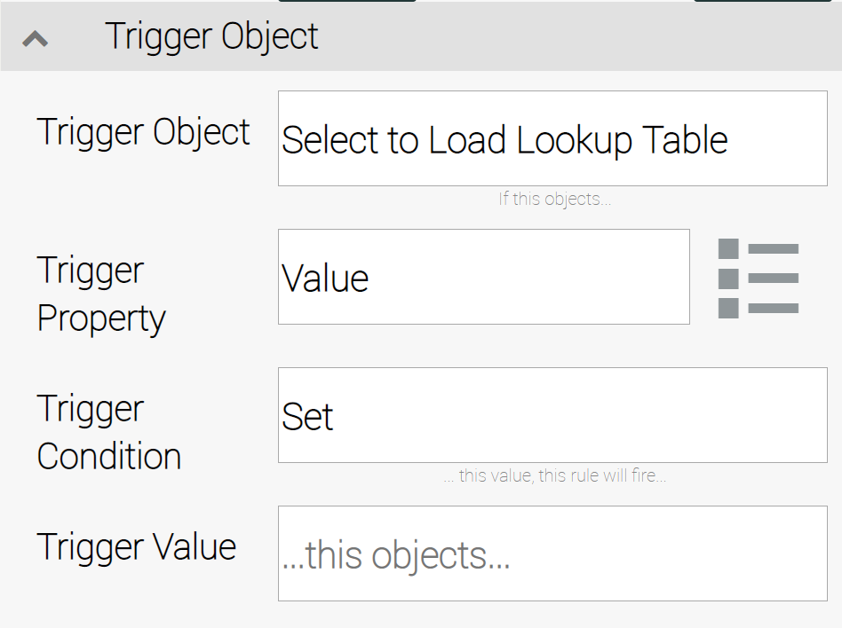  
**Figure 3.2. Settings in the Trigger Object group.**

**Trigger Object**: The Thing being monitored. The prompt "Select to Load Lookup Table" appears when this value has not been set. Click to access the Thing Chooser support.

**Trigger Property**: Once a Trigger Object has been selected and loaded, the selection list holds all the properties from which a trigger property can be selected. Select one property to use.

**Trigger Condition**: The Trigger Condition describes how the trigger property is to be used to set a specific condition to monitor. The available conditional operators are summarized in this table:

| Trigger Condition | Description |
| --- | --- |
| Contains | Trigger property contains the value specified in “Trigger Value” |
| EndsWith | Trigger property ends with the value specified in “Trigger Value” |
| Equals | Trigger property is equal to the value specified in “Trigger Value” |
| Fire | Fires the action if the property of the trigger object changes, no matter to what it changes to. |
| Flank | The action will be fired if the trigger property changes between two values specified in the Trigger Value. For example, “1,2” fires the action if the property value changes from 1 to 2. Other examples are “3,1”, a negative flank when the value in the trigger objects changes from 3 to 1. |
| Larger | Trigger property is larger than the value specified in “Trigger Value” |
| Not | Trigger property is not the value specified in “Trigger Value” |
| Set | Trigger property is set to the value specified in “Trigger Value” |
| Smaller | Trigger property is smaller than the value specified in “Trigger Value” |
| StartsWith | Trigger property starts with the value specified in “Trigger Value” |
| State | Fires the action if a change has been reported and the previous value is the same as the current value. |

**Trigger Value**: This is an editable text field for specifying the value needed to complete the trigger conditional expression.

## Action Settings

When the specified condition on a trigger object is met, an action must be taken. The Action Settings fields specify one of three possible types actions that can be taken along with an optional waiting period before the action is carried out. The Action Settings are shown in figure 3.3.

**Action Object Type**: Defines the action to be executed when the trigger object condition is met.

* Set Property on a Thing: sets a property of a Thing to the “Action Value” specified in the “Thing/Property Action” section (default).
* Publish Central: Sends a message to all nodes in the mesh with the given parameters specified in the “TSM Action” section.
* Publish to Service: sends a message to a specific service in the mesh.

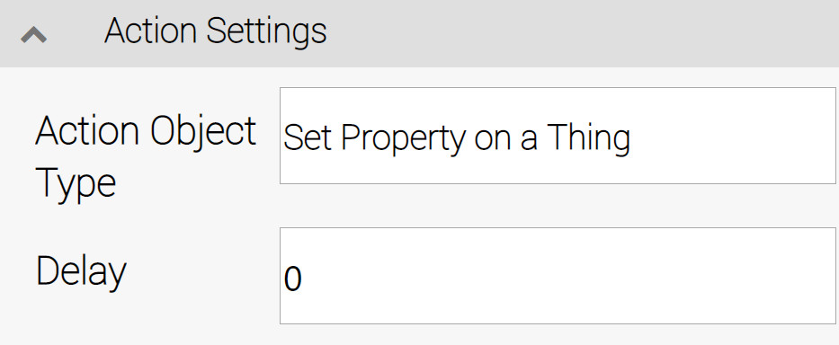  
**Figure 3.3. The Action Settings group.**

**Delay**: Specify the number of seconds to delay prior to triggering the action.

## Thing/Property Action settings

When the Action in the action settings group is "Set Property on a Thing", this group of settings defines the value, and the object and property to which the value is to be assigned (see Figure 3.4).

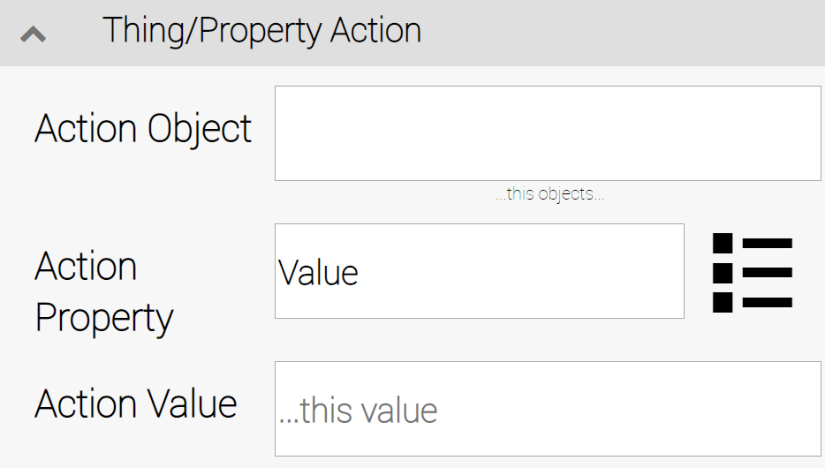  
**Figure 3.4 The Thing/Property Action settings group.**

**Action Object:** The “Thing” (object) that contains the property to be changed when the trigger condition is met.

**Action Property**: Select to load a lookup table of all available properties of the action object.Default is: **Value.**  Click on “more options button” to expose all available properties for the Selected Action Object.

**Action Value:** Specify the value to be put in the property of the thing specified above.

## TSM Action Settings

When the action object is set to “Publish Central” or “Publish to Service”, then when the trigger condition is met, a TSM message gets sent. (TSM stands for "The System Message".)

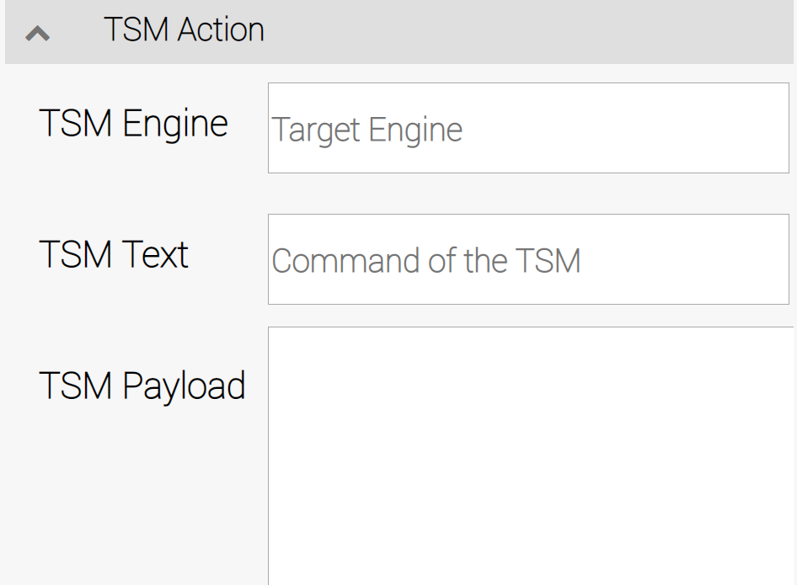  
**Figure 3.5. Settings in the TSM Action group.**

**TSM Engine**: When the trigger condition is met, a message is sent to the engine named in this field.

**TSM Text**: ­­­­Specify the command/text (TSM.TXT) of the message. Target plugins use the TXT potion of the message as one of two parameters.

**TSM Payload**: Specify the second parameter to accompany the message, the PLS (TSM.PLS) value.

## Example of Using the Rules Engine

Chapters 3-6 provide examples of setting up three example rules, which operate on three objects which we refer to as “Machine A”, “Machine B”, and “Machine C.” Details about setting up the three machine objects are provided in chapter 3.

Machines “A, B” and “C” are represented by virtual countdown controls named “M1”, “M2” and “M3”. (Details on configuring the email recipient is provided in Appendix C).

Here’s a list of rules we will create:

**Rule #1 (chapter 3):**

When Machine “A” completes counting down from 3,

Machine “B” starts counting down from 10.

**Rule #2 (chapter 4):**

When Machine “B” counts down to 4,

Machine “C” starts counting down from 7.

**Rule #3 (chapter 5):**

When Machine “C” reaches the count of 2,

Message Plugin will send out a notification email.

Before we can start creating rules, however, we need an environment to work in. Chapter 3 provides instructions on using the Virtual Things plugin to simulate Machines 1 to 3.

Note: These example rules use the Virtual Things plugin and the Message plugin. For further details, consult the configuration guide for each plugin.

# Setting up the Machine Environment

Follow these steps to set up the countdown timers we will be using to simulate the machines for the three examples of rules for the Rules Engine.

1. Open the Virtual Things plugin and click on the **V-Things List** tile on the dashboard.

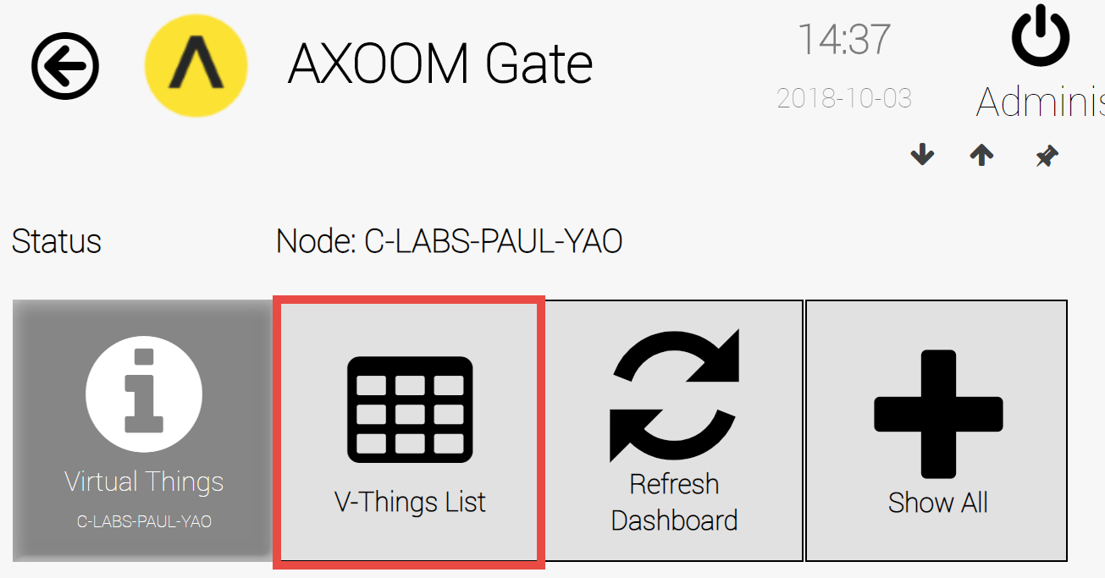  
**Figure 4.1. The Virtual Things dashboard.**

1. The Virtual Things list appears. Click on the **Refresh** button to load all current virtual things. (In Figure 4.2, none have yet been created.)

## Create Countdown Timer for Machine M1

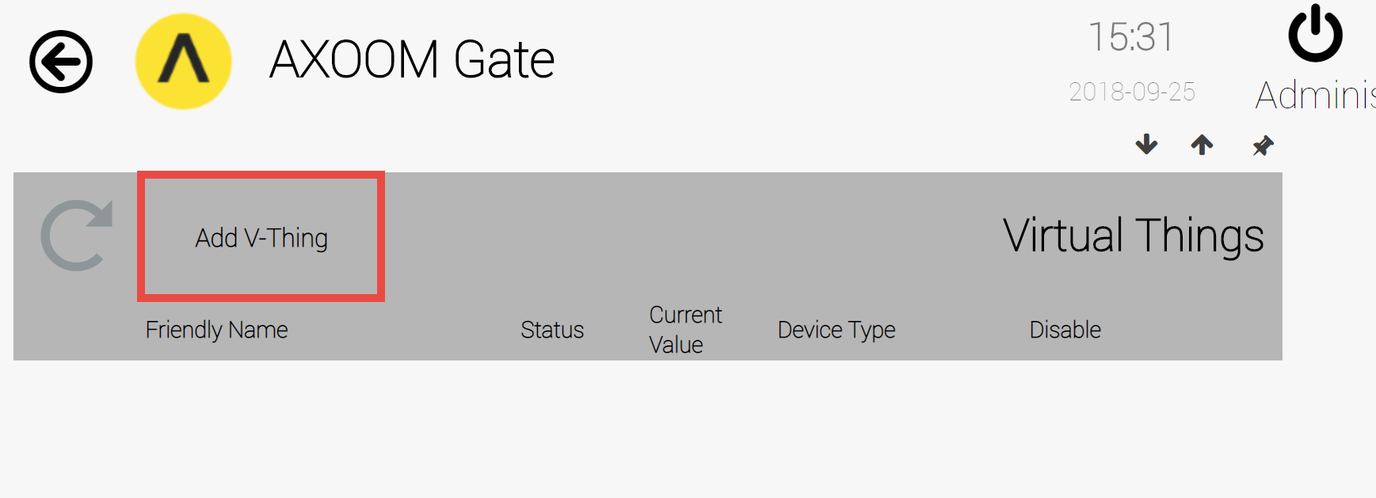  
**Figure 4.2. Click the Add V-Thing button.**

1. To create a virtual thing, click on the **Add V-Thing** button.
2. A blank row appears. Enter the following data into the newly created row (see Figure 4.3).
3. Give your virtual thing a friendly name of **M1**.
4. A status light will display after the virtual thing has been created. For now, it appears as an empty field.
5. Click the **Device Type** field and select **Countdown**.
6. Click the **Save** button.

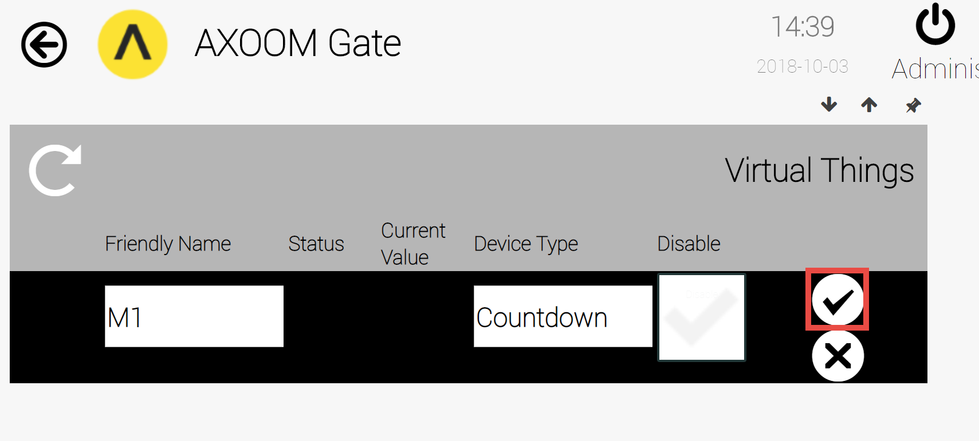  
**Figure 4.3. Click the Save button to save the countdown timer.**

1. Configure Countdown M1 Control:
   1. Click the **Properties** icon () to open the settings page (see Figure 4.4).

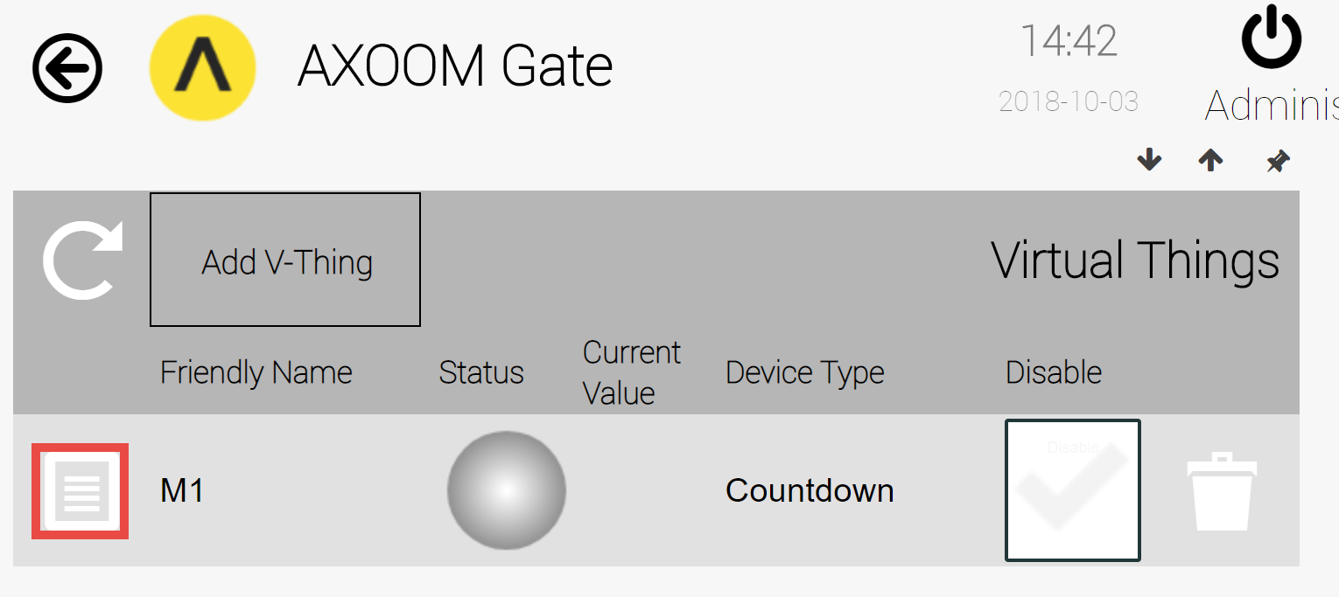  
**Figure 4.4. Click the properties icon to summon the settings page.**

1. As shown in Figure 4.5, when the settings page first loads, one of the two settings groups are visible. The **Device Status** settings are visible. Click on the **Settings** tab (highlighted in Figure 4.5) to expose the second settings group.
2. Enter the following values into the fields in the second settings group (see Figure 4.6):

Start Value: 3

Tick time in ms: 1000

Continue on Restart: leave unchecked

Start Over when zero: leave unchecked

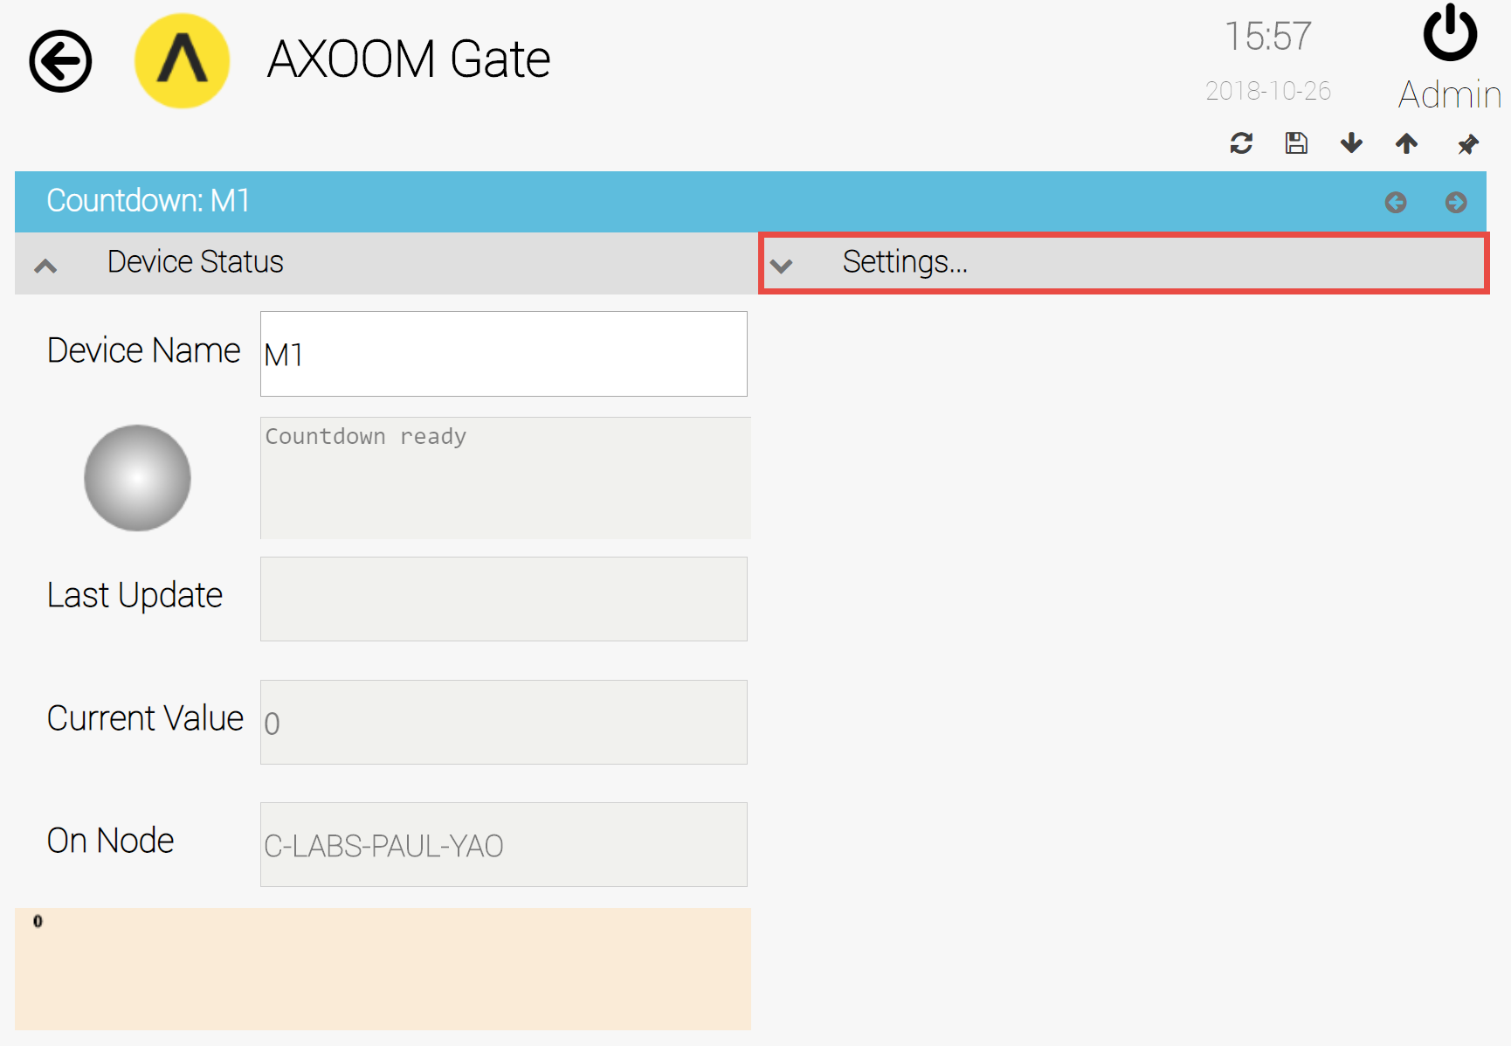  
**Figure 4.5. The countdown settings page.**

1. Click the back button () to return to the page showing the Virtual Things table.

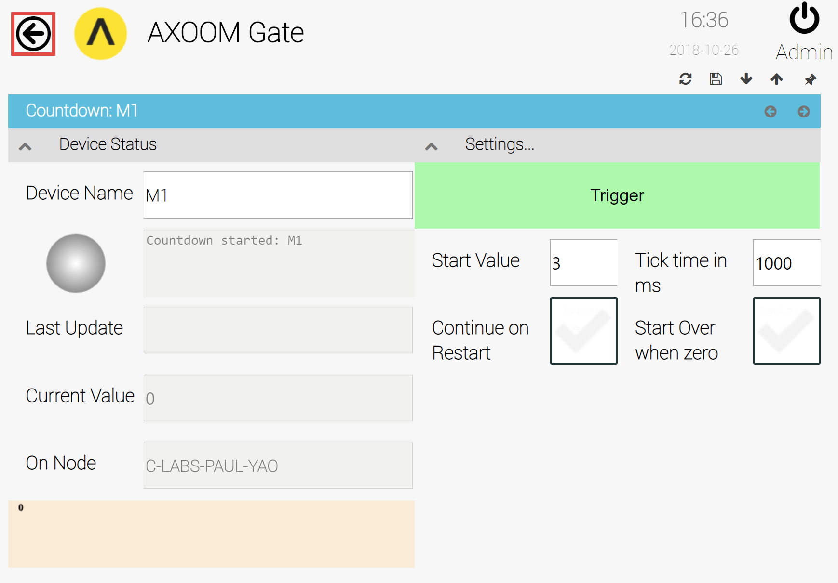  
**Figure 4.6. After entering the values for Machine M1, Click the Back button (highlighted).**

## Create Countdown Timers for Machine 2 (M2) and Machine 3 (M3)

Create two more countdown timers by following steps 2 through 8 two more times, using the following input values:

Data for Countdown M2:

Start Value: 7

Tick time in ms: 1000

Continue on Restart: leave unchecked

Start Over when zero: leave unchecked

Data for Countdown M3:

Start Value: 10

Tick time in ms: 1000

Continue on Restart: leave unchecked

Start Over when zero: leave unchecked

After all three of the countdown controls have been created, the Virtual Things table will appear like the example in Figure 4.7.

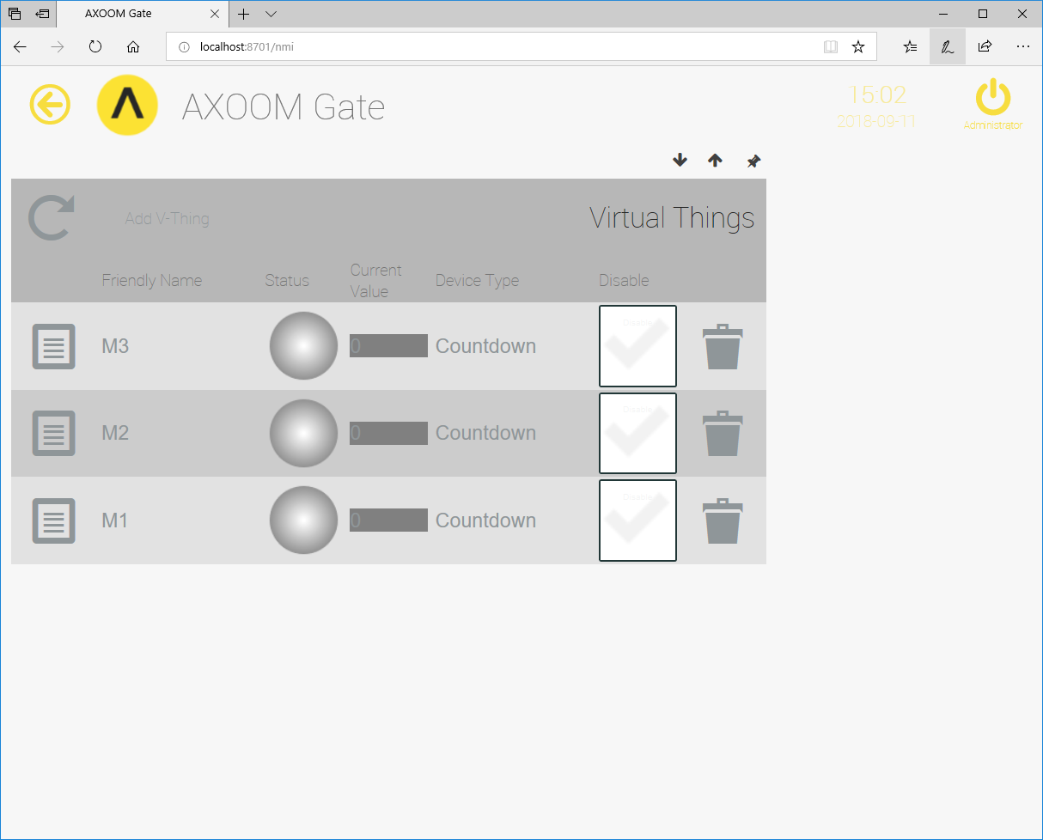  
**Figure 4.7. Virtual Things plugin with three countdown timers.**

# Example: Setting Up Rule #1

When the Rules Engine plugin is installed, one rule is created for you. When working with rules, you can either:

* Use the existing rule by clicking on the “My First Rule” tile on the Rule Engine dashboard.
* Create a new rule from the Rules Registry, clicking on the Add Rule button, then editing the settings for the newly-created rule.

For the first rule, we are going to using the existing rule.

**Rule 1:**

When Machine “A” completes counting down from 3, Machine “B” starts counting down from 10.

The three steps to configuring our first rule are summarized in Figure 5.1.

**Figure 5.1. A summary of the three steps to take to set up the first rule.**

## Step One: Define the rule

Enter name of the rule – here we keep it simple “**Rule1**”. We want to make the rule active, so click on the **Activate Rule** checkbox. For the purposes of this example, we do not need to log this rule so leave the **Log Rule** box unchecked.

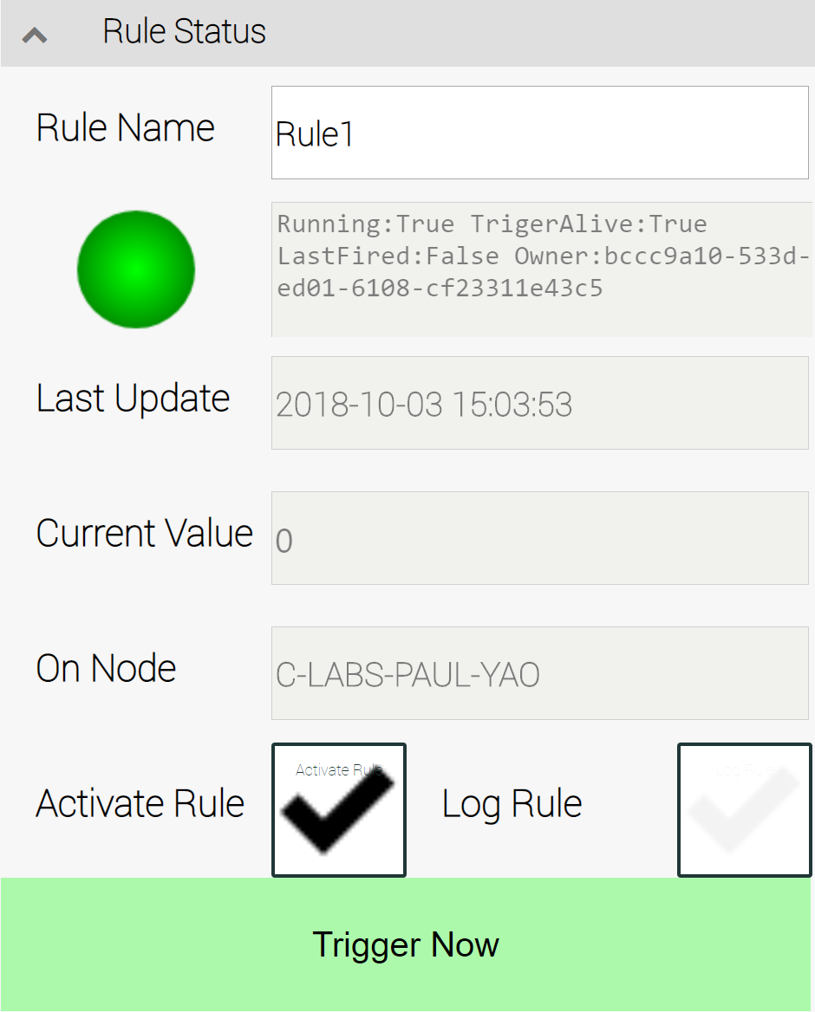  
**Figure 5.2. Step 1: Define the rule.**

## Step Two: Define Trigger Object

Trigger Object refers to the object we want to monitor. In Rule 1, that’s Machine “A” (**M1**), specifically, we need to monitor its Trigger Property: **Value**. We are monitoring for the countdown to be complete, which means when **M1** reachs the count of zero (M1**=** **0**). Trigger Condition: **Equals** and Trigger Value: **0**.

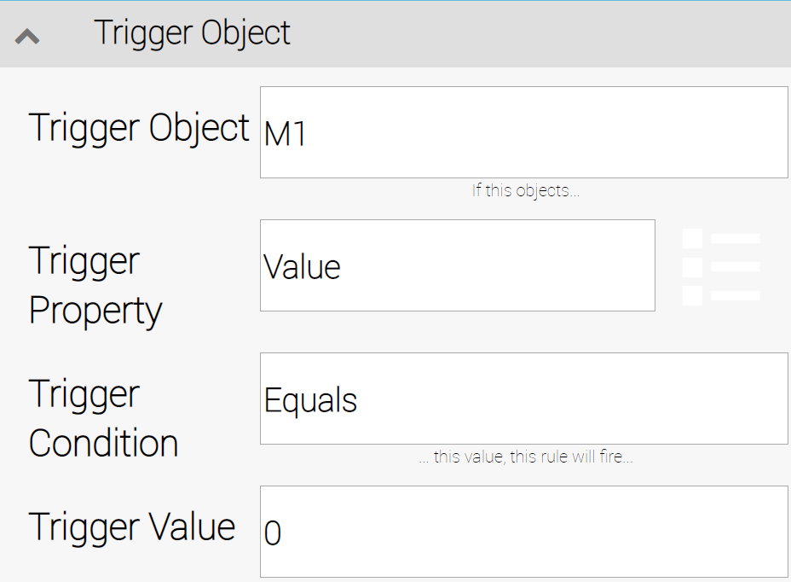  
**Figure 5.3. Step 2: The Trigger Object defined.**

## Step Three: Set Action Object

The third step is to define the object to act on and what action to take. For this, we modify items in the **Action Settings** group and in the **Thing/Property Action** group. In the **Action Settings** group, use these settings:

* Action Object Type: **Set Property on a Thing**.
* Delay: 2.

In the **Thing/Property Action** group, using these settings:

* Action Object: M2 (for Machine "B")
* Action Property: **StartValue**
* Action Value: 10

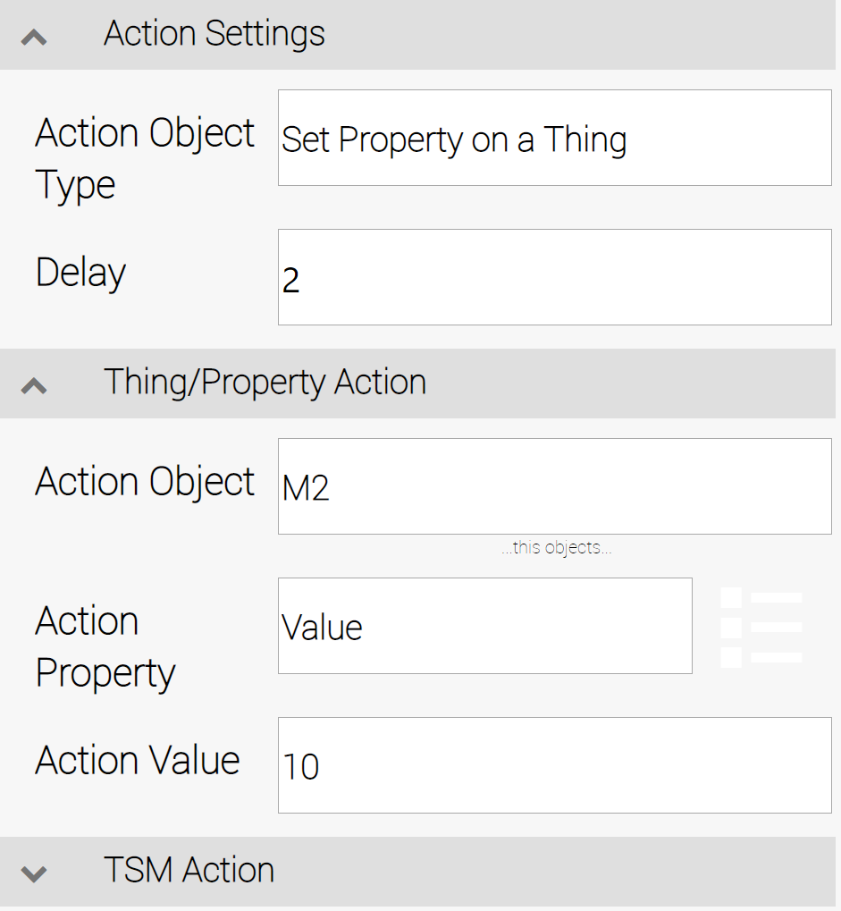   
**Figure 5.4. Step 3: Define Action Settings and Thing/Property Action.**

## Testing Rule #1

You are now ready to test your first rule. Follow these steps to organize the elements of AXOOM Gate within your browser to make it easy to observe **Rule 1**. We will use the pin icons, located in the upper-right corner of each page, to lock specific elements in place. The C-DEngine lays out items in a similar manner as HTML, so we will create our view from right to left.

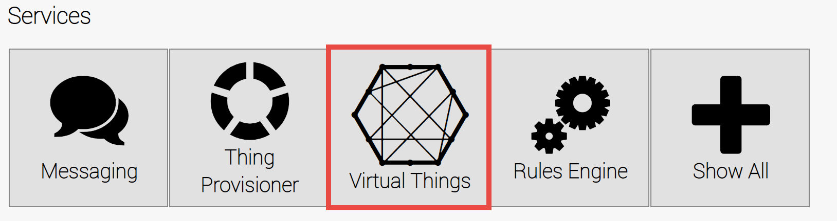  
**Figure 5.5. From the AXOOM Gate main page, click on Virtual Things plugin.**

1. Start on the AXOOM Gate main page.
2. Click on the Virtual Things button (see Figure 5.4).
3. This opens the dashboard of the Virtual Things plugin, which displays the available virtual things (see Figure 5.5).
4. Click on the M2 item, which opens the M2 settings page.
5. If it isn't already open, click on the **Settings** header so that the options in that group are visible.
6. Click on the left-facing gray arrow () to collapse the settings page to one column (see Figure 5.6).

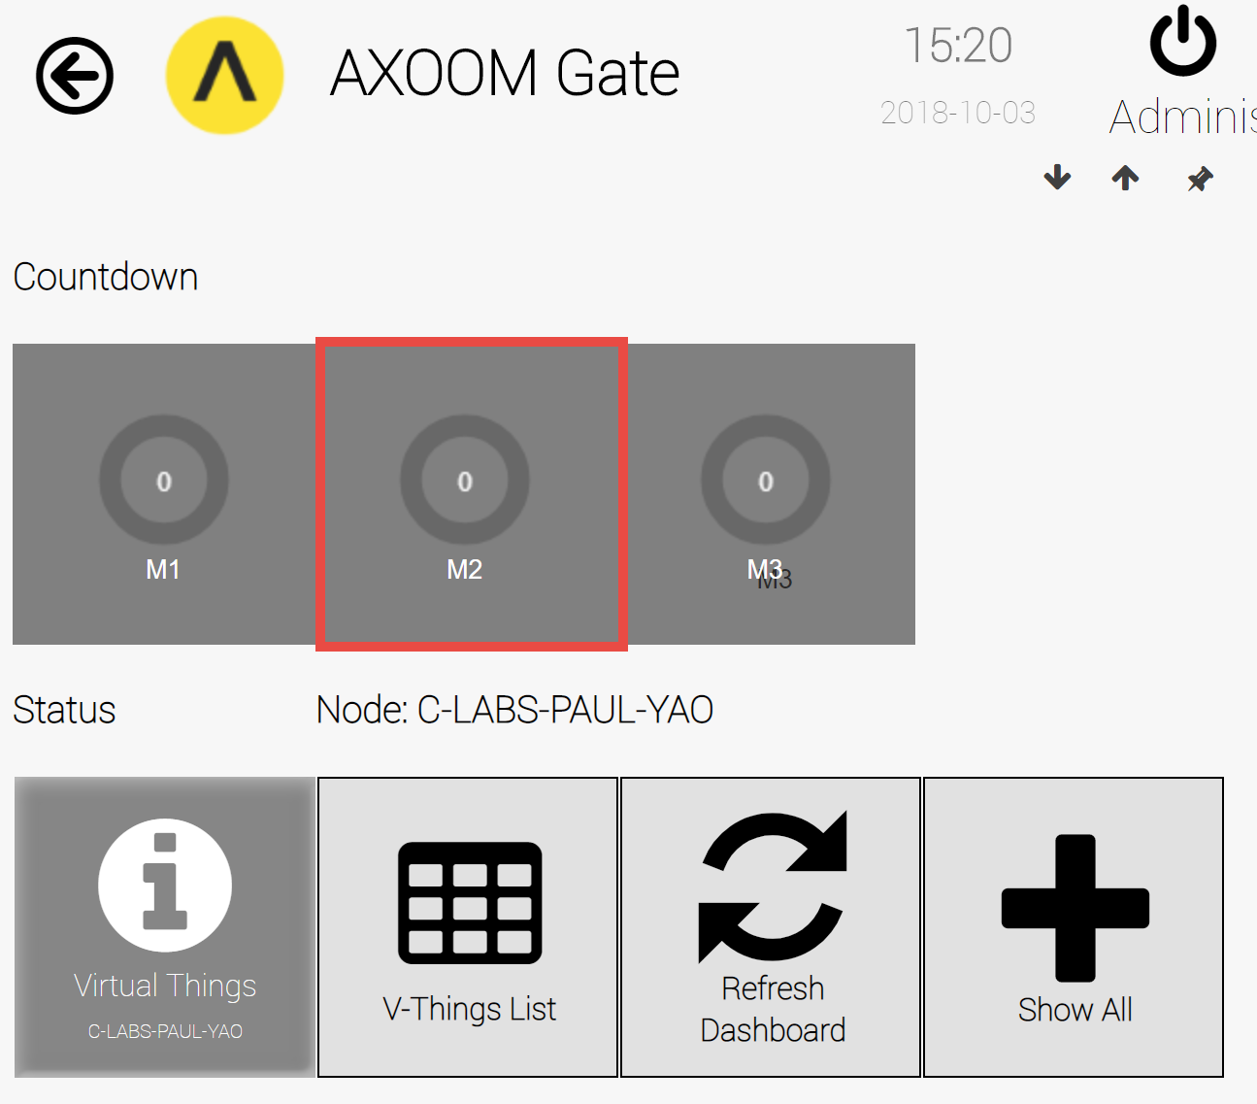  
**Figure 5.6. Virtual Things plugin dashboard with three countdown timers M1, M2, and M3.**

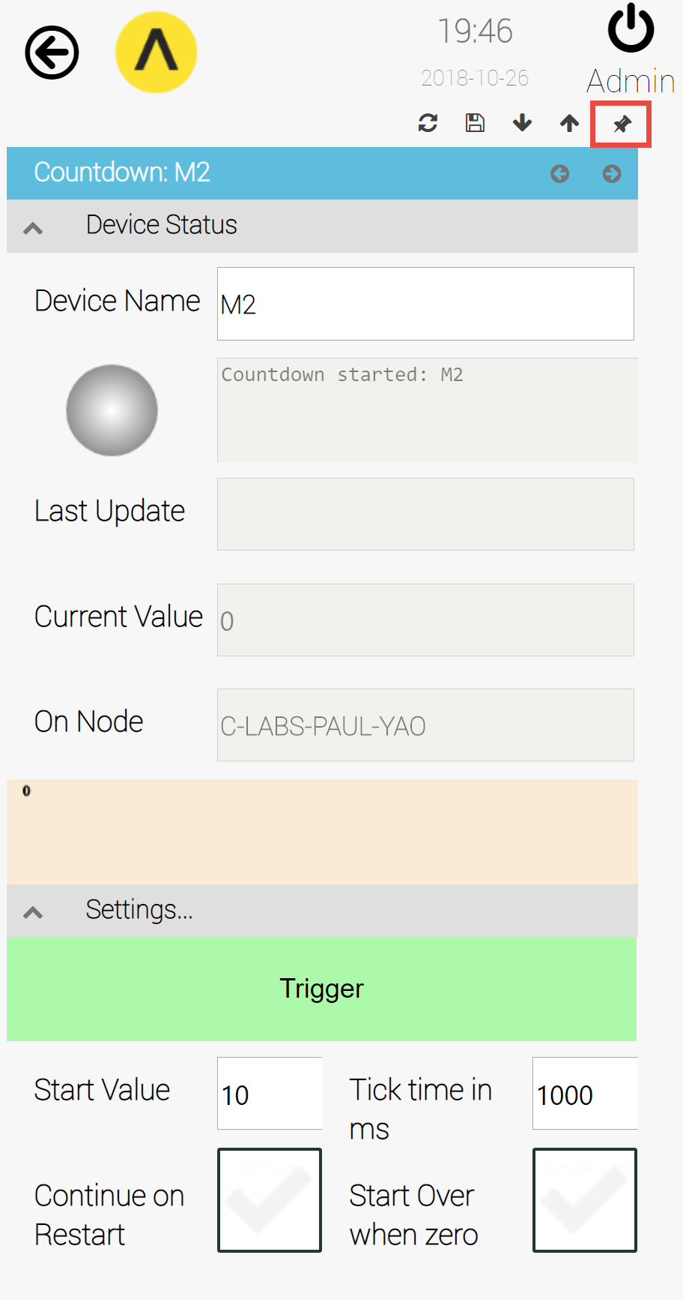  
**Figure 5.7. The collapsed M2 Countdown settings page, with pin icon highlighted.**

1. Click the pin icon (), in the upper-right corner of the settings page, to lock the window onto the screen. The pin toggles between the unlocked state and the locked state (). If you navigate to the home page of AXOOM Gate, by clicking the home icon (, located on the upper-left side of the page), the pinned page continues to be visible (see Figure 5.7).

: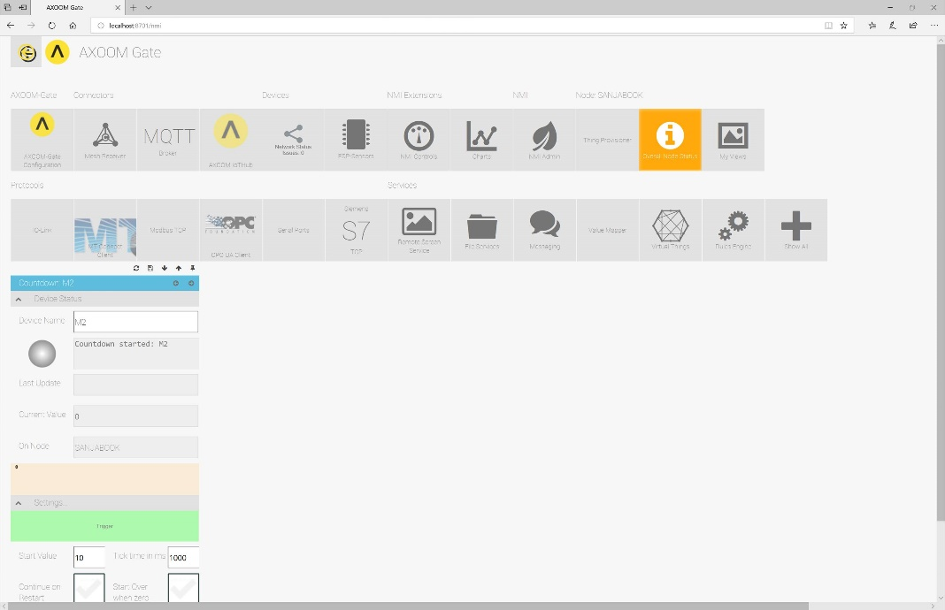  
**Figure 5.8. M2 detail form pinned to dashboard.**

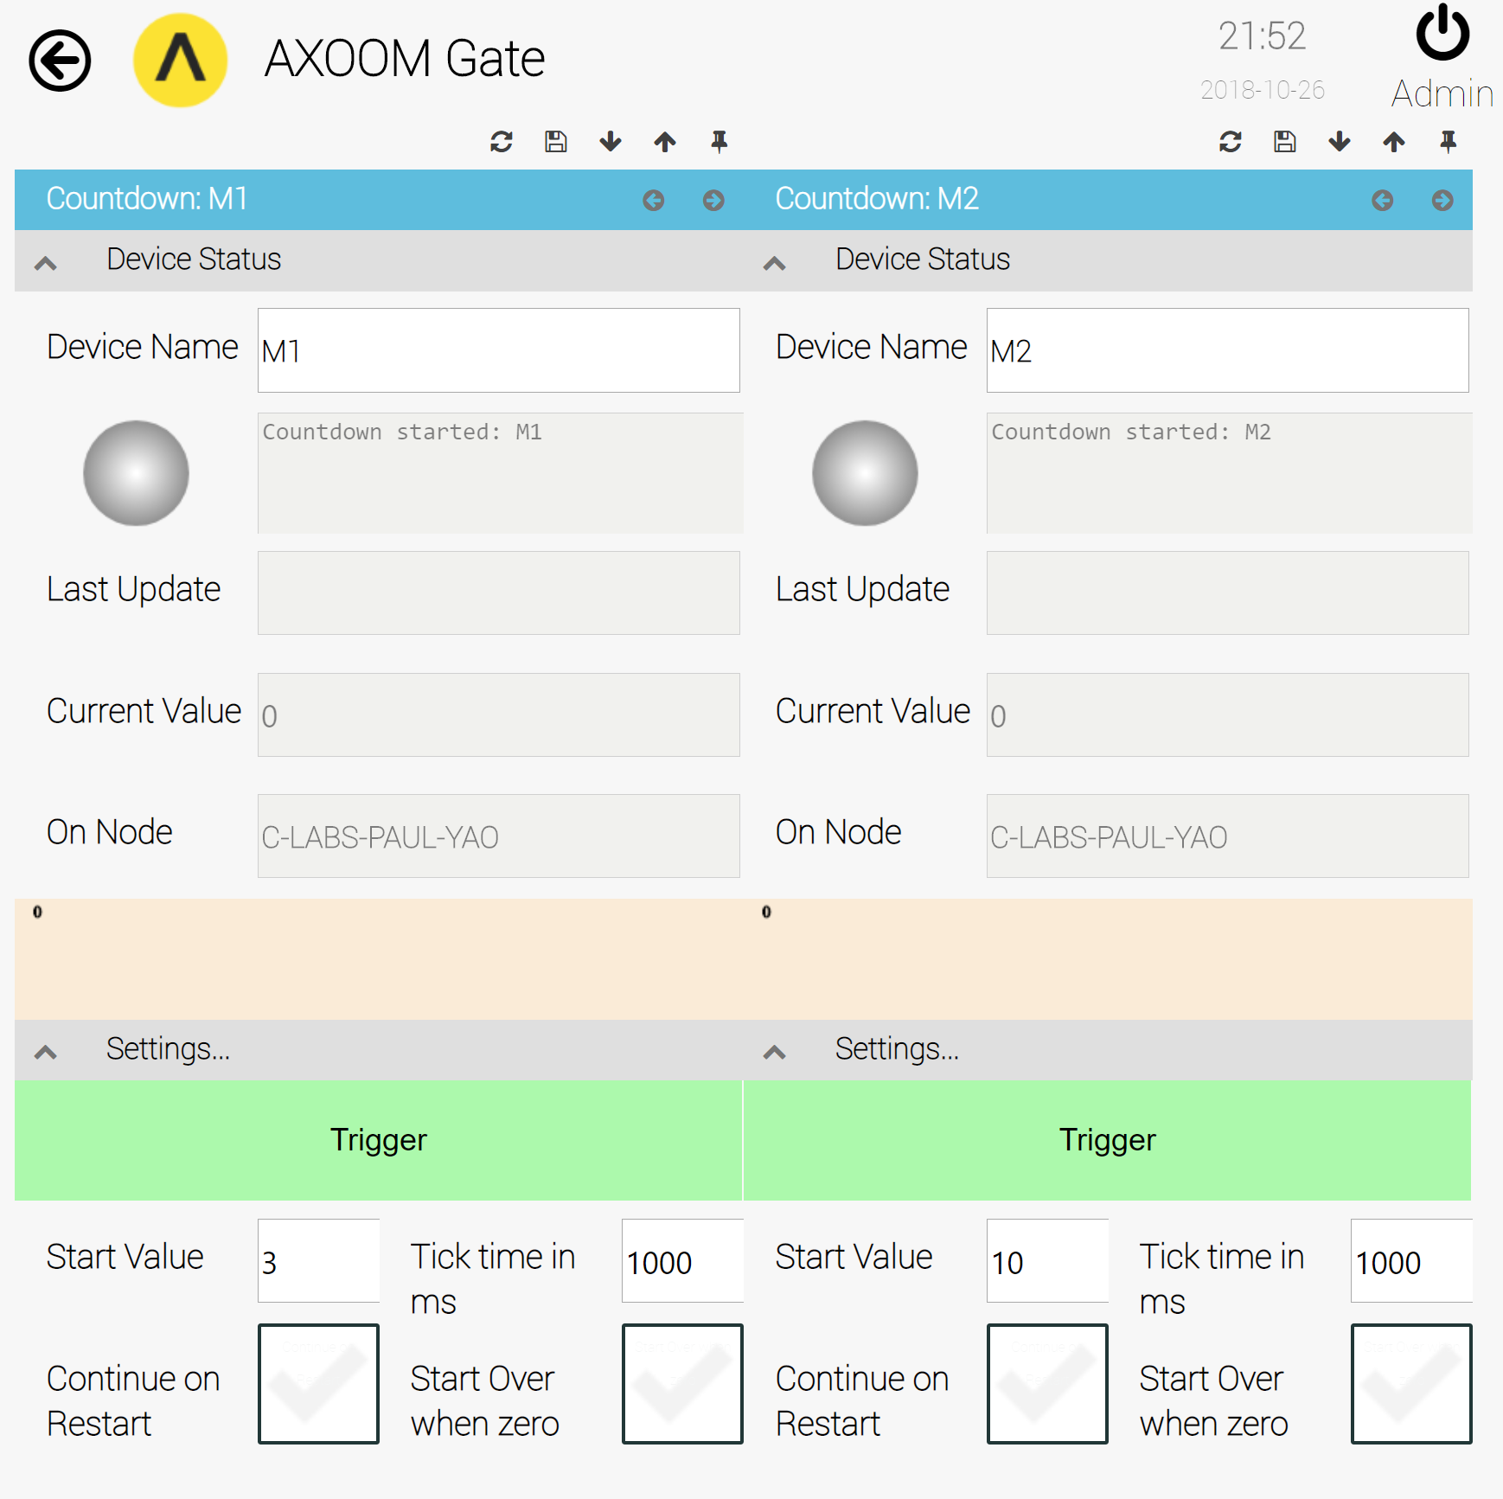  
**Figure 5.9. The pinned settings pages for M1 and M2.**

1. Follow the same steps to pin the M1 countdown timer settings page (see Figure 5.8).
2. Next, we are going to run a test of the rule we created earlier. To do this, navigate to the Rules Engine dashboard.
3. On the Rules Engine dashboard, click on the icon for the rule we created earlier. Figure 5.9 shows how the screen might appear, with Rule 1 occupying the left side of the browser window with our two machine simulators, M1 and M2, occupying the right side of the browser window.

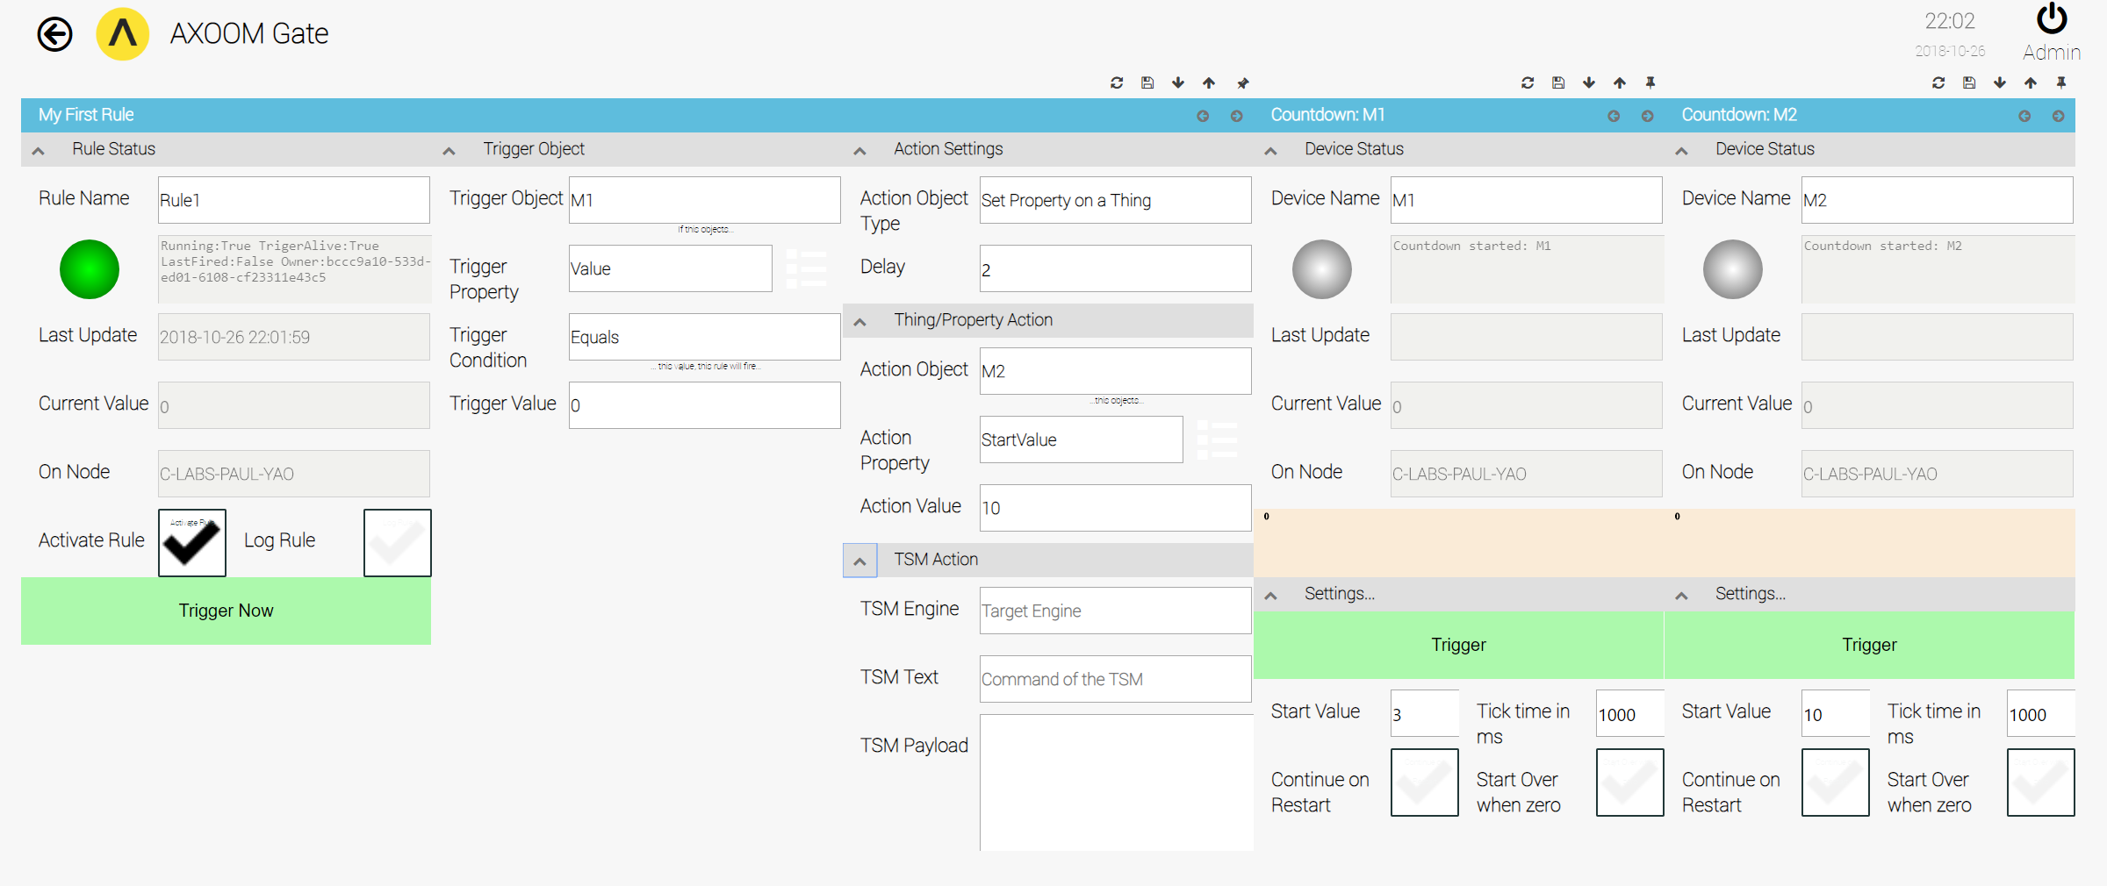  
**Figure 5.10. Rule 1 appearing with two countdown timers, M1 and M2, ready for testing.**

1. We are almost ready to test Rule 1. First, simplify the screen display by closing all of the settings groups in Rule 1, except the left-most one, **Rule Status**.
2. Next, shrink the space being occupied by Rule 1 by collapsing the window using the  icon.
3. Finally, pin Rule 1 by clicking the pin icon in the upper-right corner of the rule setting page. Our more compact view appears in see Figure 5.10.
4. To save the view, and make it available later, follow the instructions in the information box labeled "Saving a View".
5. To test if Rule 1 works, click the **Trigger** button on Countdown:M1. After the M1 countdown reaches zero, you will see how our Rule 1 causes the Countdown:M2 timer to be reset and to run.

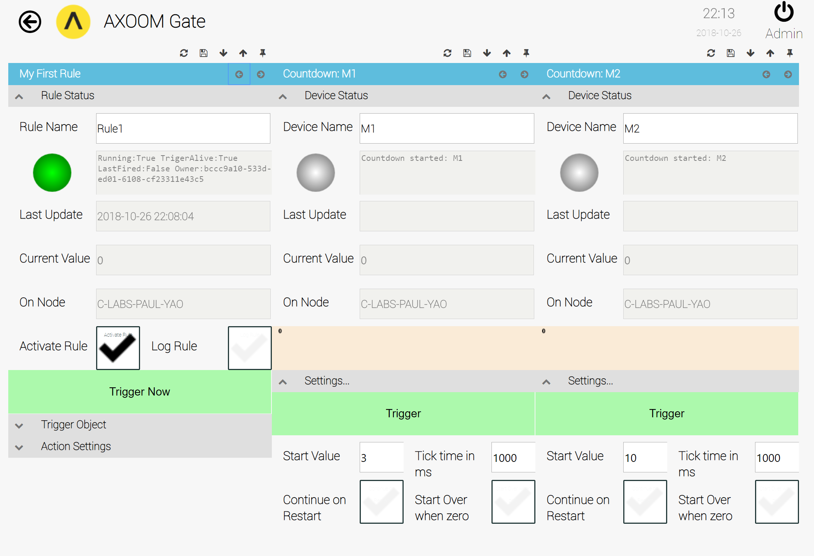 **Figure 5.11. A more compact display with one column each for the rule, M1, and M2.**

**Saving a Scene**

To save a scene, you need to access a menu that is normally hidden. To open this menu, click on the home button () and drag it right. Here is how the top of the browser window appears when this menu is closed:   
  
When the menu is open, the top of the browser window appears as shown here:  
  
Click on the highlighted icon to save the scene. You will be prompted to provide a name for the scene (see Figure 5.11).   
  
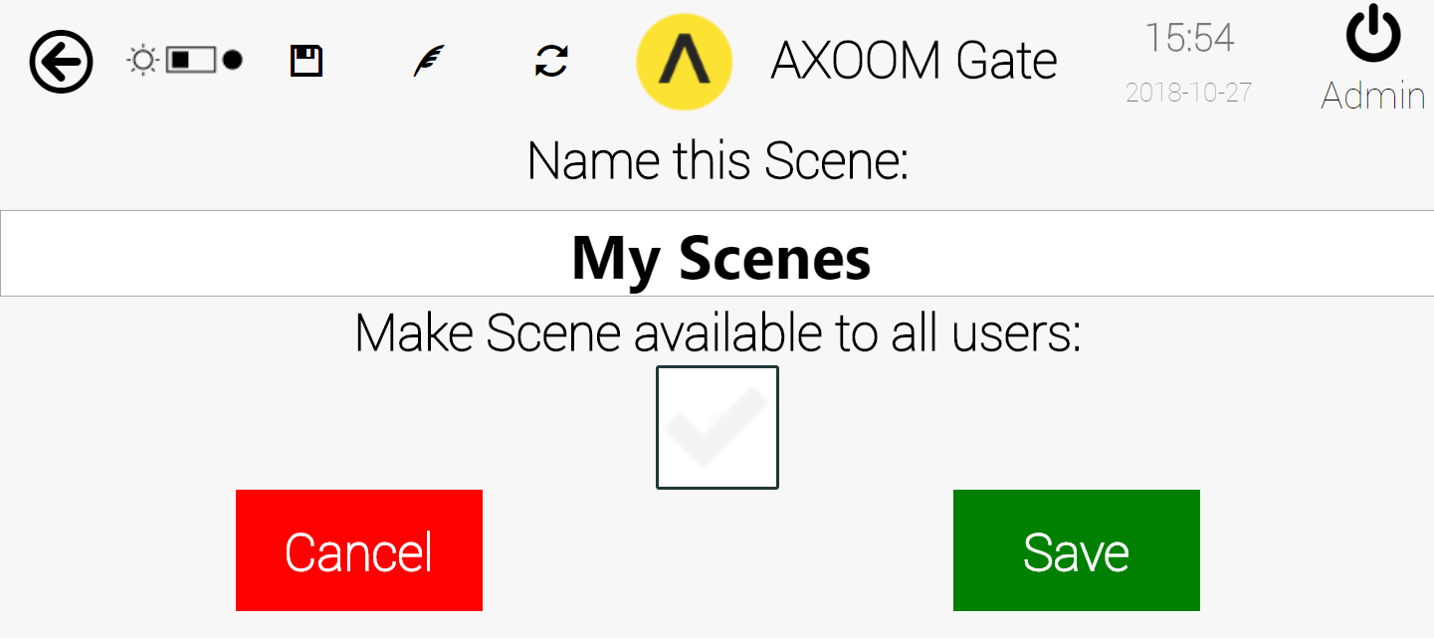  
**Figure 5.12. Provide a name for the scene, then click the Save button.**

**Loading a Scene**

To load a scene, start by clicking on the **NMI Admin** button (see Figure 5.12) on the AXOOM Gate home page.

  
**Figure 5.13. The NMI Admin button.**

Next, click on the **My Scenes** button (see Figure 5.13), which summons a list of available scenes.

  
**Figure 5.14. The My Scenes button.**

You may need to click on the Refresh button () at the top of the My Scenes table. Click on the **Load Scene** button next to the scene you wish to load (see Figure 5.14).

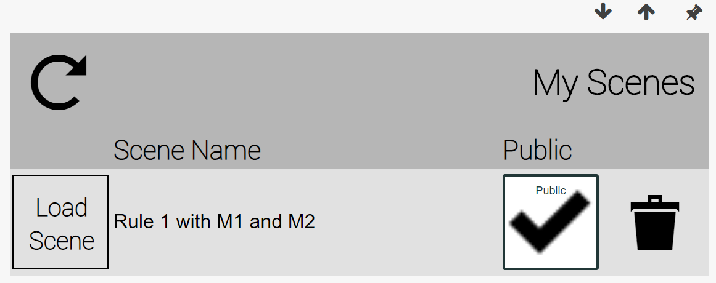  
**Figure 5.15. The My Scene Table.**

C-Labs\C-Labs VIDEOS\Rules Engine\TestRule1.avi

# Example: Setting Up Rule #2

**Rule 2:**  
When Machine “B” counts down to 4, Machine “C” starts counting down from 7.

In the previous example, we used the existing **My First Rule** for Rule 1. For Rule 2, we create a new rule. Configure Rule 2 following the three steps summarized in Figure 6.1. Create the rule in the rules registry table.

**Figure 6.1. Three steps for creating Rule 2.**

## Rules Registry Dashboard

When you open the Rules Registry table, click the Refresh button  to load the existing rules.

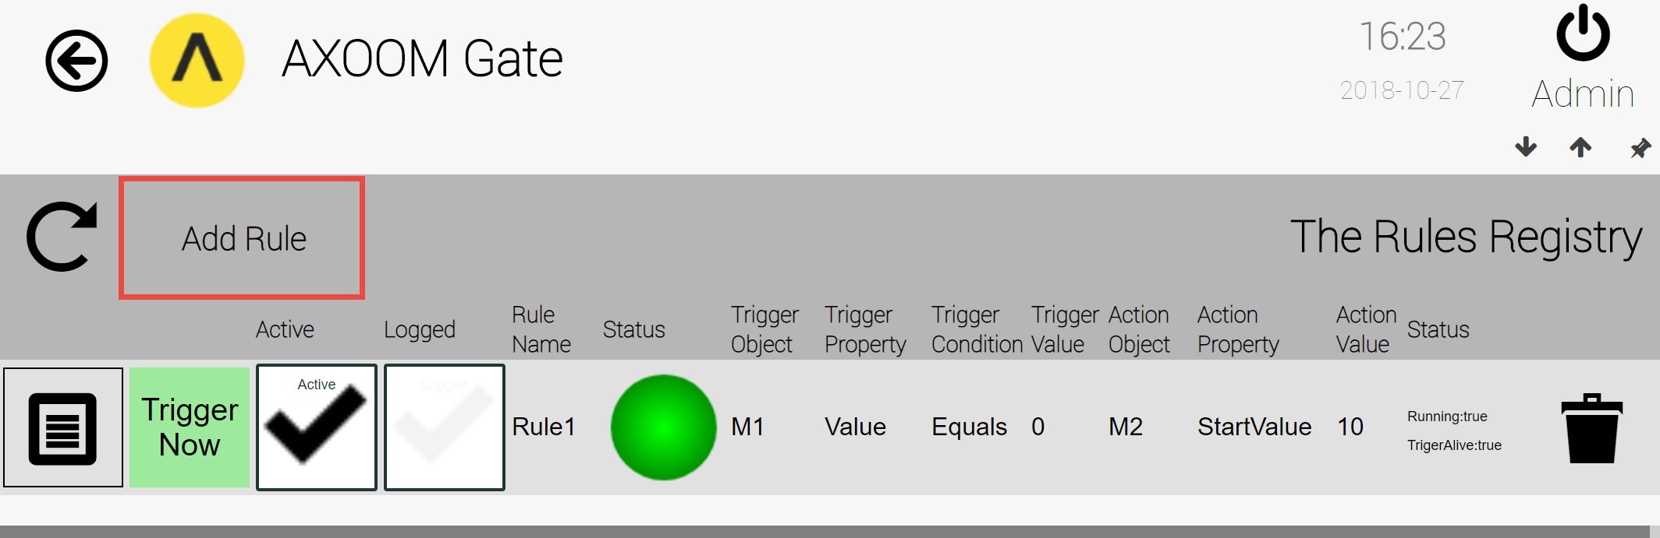  
**Figure 6.2. Rules Registry table.**

## Creating a new rule

Click the Add Rule button in the top left corner of the Rules Registry.

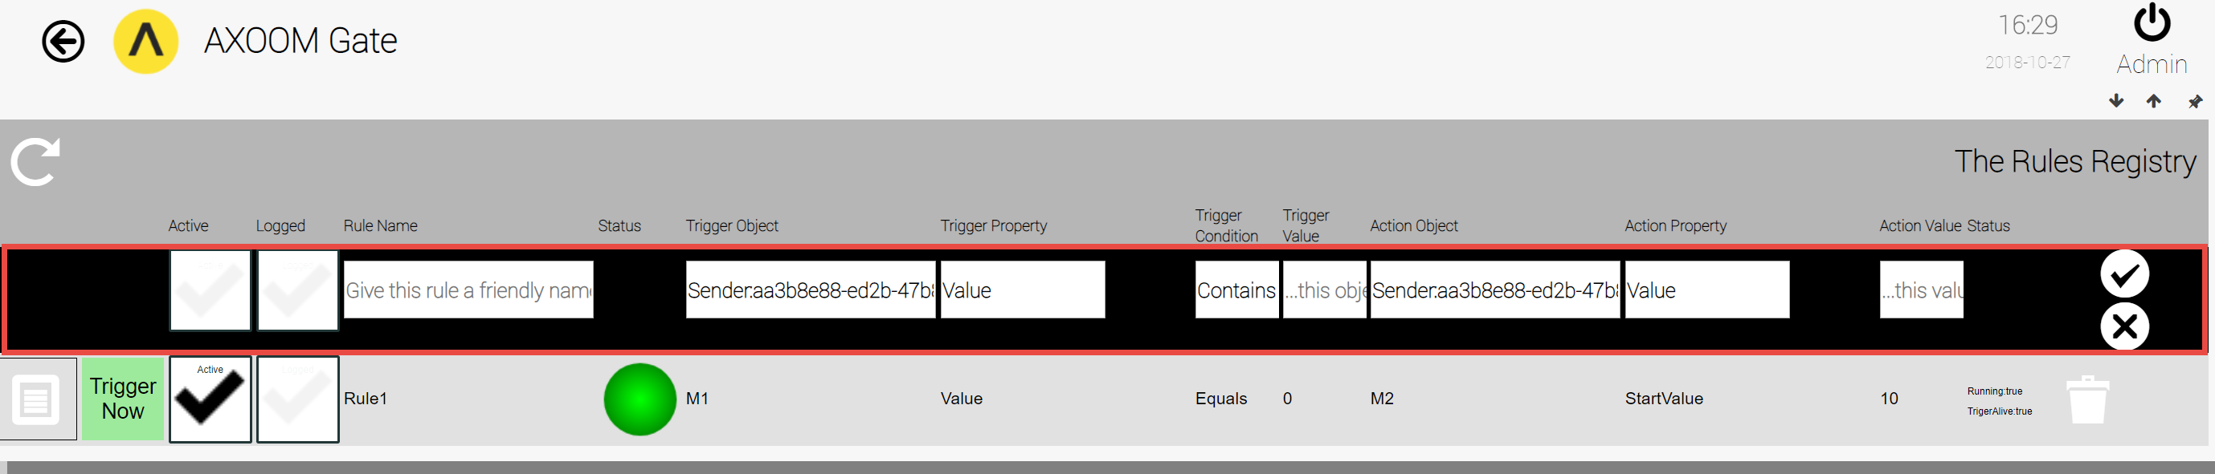  
**Figure 6.3. Adding a rule in The Rules Registry.**

Enter the new rule values using these settings:

* Click on the **Active** checkbox.
* For the **Logged** checkbox, leave it empty since we do not require logs.
* For the **Rule Name**, enter **Rule2**.
* In the **Trigger Object** field, click in the field to start the selection process. Then click on **SELECT** button to load available options. Click again in the **Trigger Object** field. Locate **Countdown** control named **M2**.
* For **Trigger Property**, keep the default value of **Value**.
* Set **Trigger Condition** to **Equals.**
* Set **Trigger Value** to **4**.
* For **Action Object**, select the value of **M3.**
* For **Action Property**, set the value to **StartValue**.
* Set **ActionValue** to **7.**

Save these values by clicking the save button ().

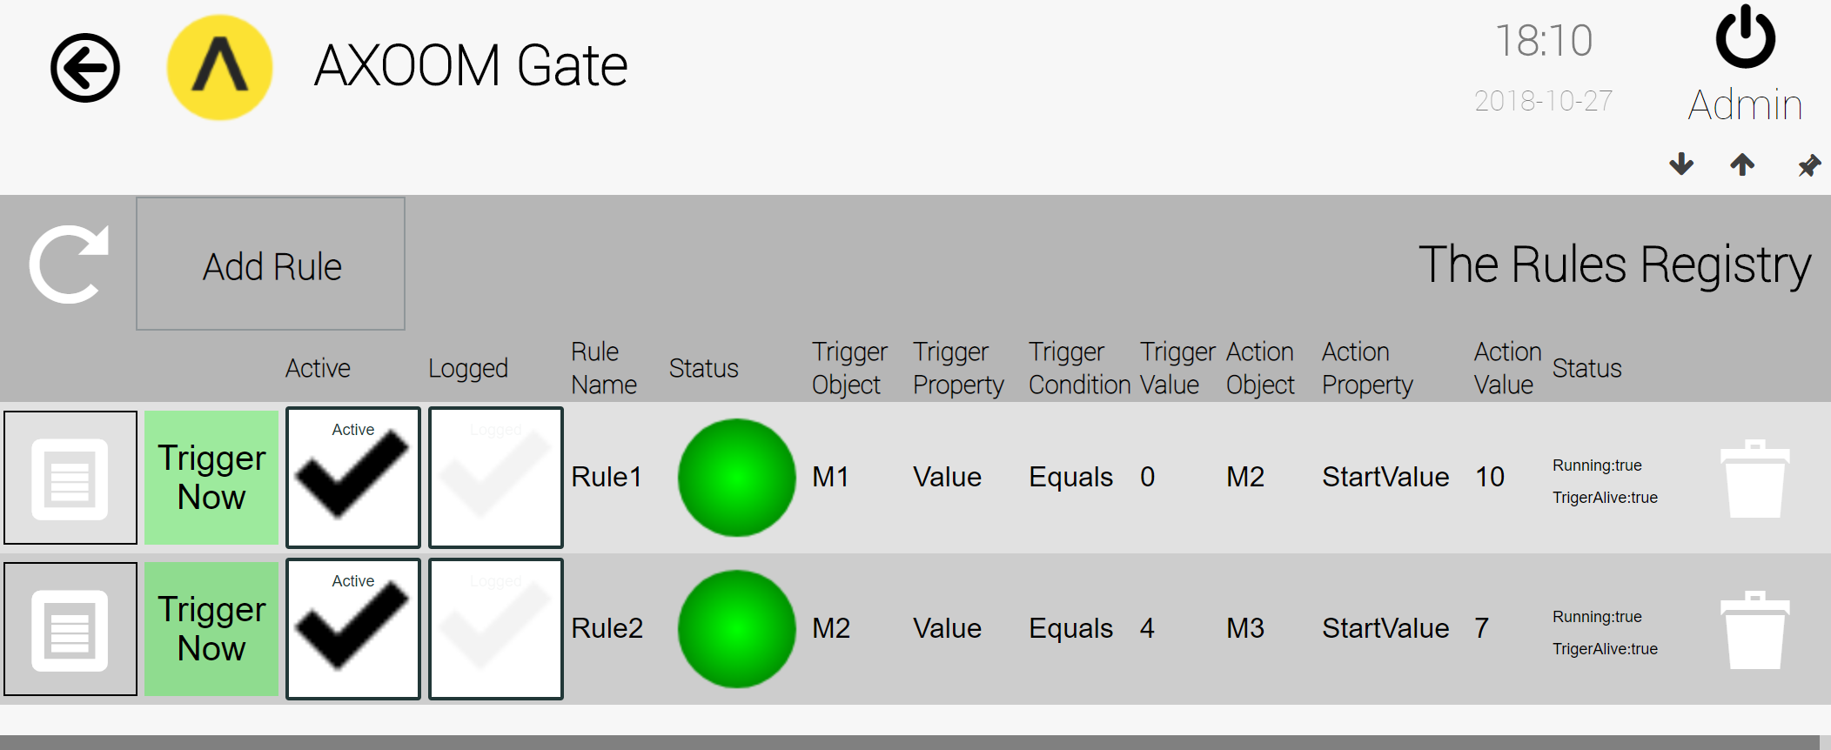  
**Figure 6.5. Rule 1 and Rule 2 in the Rules Registry.**

**NOTE**  
Rules Registry Table does not expose Action Object Type. To specify Action Object Type, first save the rule by clicking Save Button in the top right corner, then open the settings page.

## Testing Rule 2

To test Rule 2, pin all three countdown controls, M1, M2, and M3. Figure 6.5 shows one way to arrange these. Click the Trigger button on the M1 Countdown control. This causes the following to take place:

* The M1 control starts at 4 and counts down to 0.
* Rule 1 responds and sets the M2 control to 10, and M2 then counts down to 0.
* Rule 2 responds and sets the M3 control to 7, which then counts down to 0.

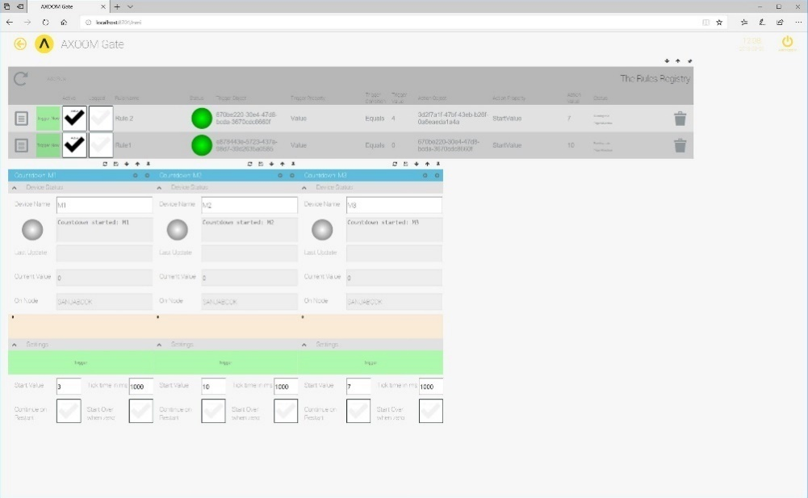  
**Figure 6.6. Testing Rule 2.**

C-Labs\C-Labs VIDEOS\Rules Engine\TestRule2.avi

# Example: Setting Up Rule #3

**Rule 3:**

When Machine “C” reaches the count of 2, the Message Plugin will send an email to notify someone about the state of the three machines.

Create a new rule, named "Rule 3", configured using the steps summarized in Figure 7.1.

**Figure 7.1. A summary of the three steps to create Rule #3.**

## Create Rule 3

In the Rules Registry, click the Add Rule button.

Step 1: Configure Rule

* Put a checkmark in the **Active** field.
* In the **Rule Name** field, enter "Rule 3".

Step 2:

* For the **Trigger Object**, select the Countdown timer **M3**.
* Leave **Trigger Property** as **Value**.
* Set **Trigger Condition** to **Equals**.
* Set **Trigger Value** to **2**.

Step 3:

* Set **Action Object Type** to **Set Property on Thing**.
* Set **Action Object** to **Messaging Plugin Object**.
* Set the value of **Action Property** to **sendmail**.
* In **Action Value**, enter the string "Process M1, M2 and M3 complete."

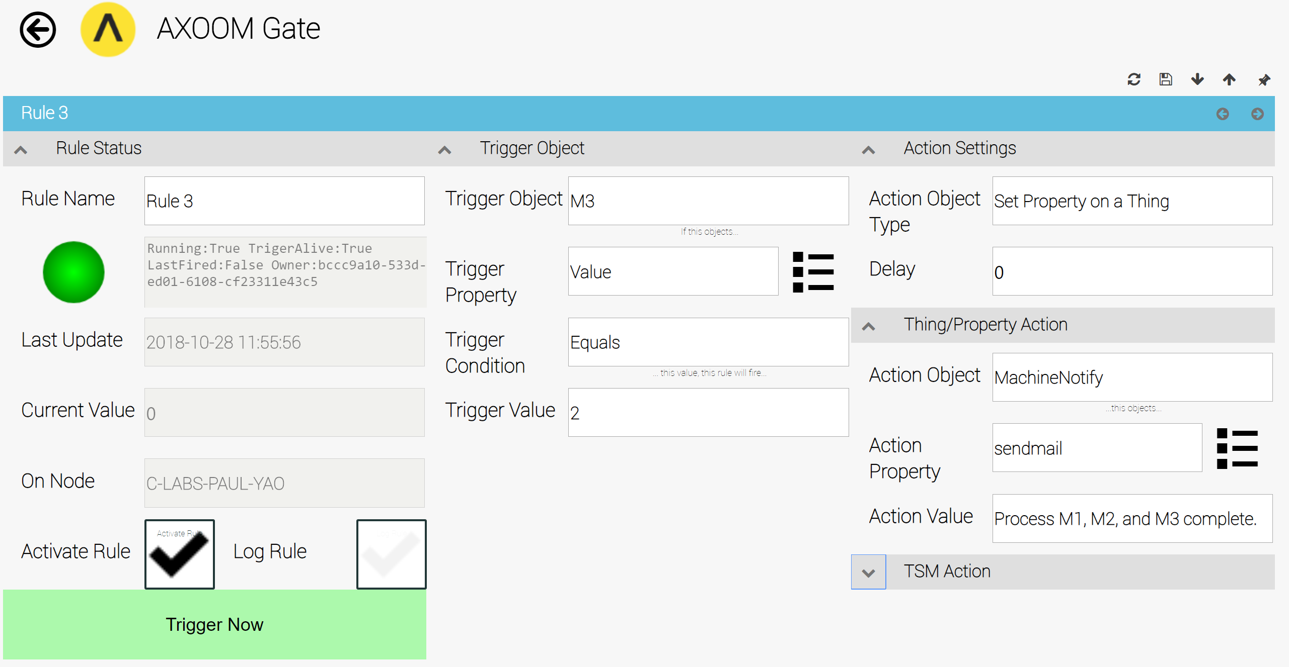  
**Figure 7.2. The settings for Rule 3.**

## Testing Rule 3

To test all three rules, scroll down to machine detail forms and Trigger M1 countdown. You can monitor the progress of the rules by observing Countdown control status lights and their current value. At the end of the test, make sure you check your email for your notification email.

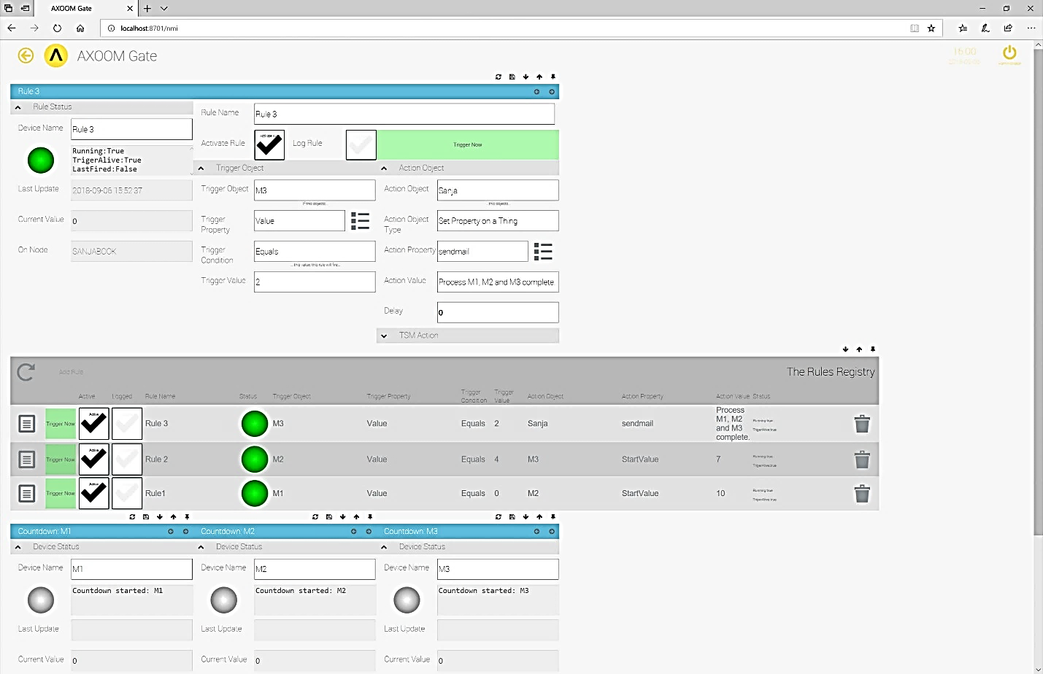  
**Figure 7.3. Testing Rule 3.**

**C-Labs\C-Labs VIDEOS\Rules Engine\TestRule3.avi**

# Appendix A: AXOOM Gate Navigation Icons

Here is a summary of the AXOOM Gate navigation icons:

| Icon | Name | Comments |
| --- | --- | --- |
|  | Home | Click to navigate to home page. |
|  | Back | Use instead of the browser’s built-in back button. |
|  | Refresh | Use instead of the browser’s built-in refresh button. |
|  | Properties | Click to view properties. |
|  | Trash Can | Delete an item. |
|  | Up arrow | Closes a group of controls. |
|  | Down arrow | Opens a group of controls. |
|  | Left arrow | Decreases the width of browser space used to display property groups. |
|  | Right arrow | Increases the width of browser space used to display property groups. |

# Appendix B: System Log Messages for The Rules Engine

| **ID** | **DebugLevel** | **EngineName** | **UserMessage** |
| --- | --- | --- | --- |
| 4445 | VERBOSE | TheThingRule | Rule {tRule.FriendlyName} stopped on Rule Update |
| 4445 | VERBOSE | TheThingRule | Rule {pRule.FriendlyName} stopped during Register Rule - waiting for startup |
| 4445 | VERBOSE | TheThingRule | Rule {tRule.FriendlyName} started with TriggerType: {tRule.TriggerObjectType} |

# Appendix C: Messaging Plugin Configuration

Configure Messaging plugin before you create rules, so that you can use newly created Message targets into the rules.

1. From the AXOOM Gate home page, navigate to the Messaging plugin by clicking the Messaging tile (see Figure C.1).

  
**Figure C.1. The Messaging Plugin tile is located on the AXOOM Gate home page.**

1. In the messaging plugin dash, click on the **Messaging Targets** button (see Figure C.2).

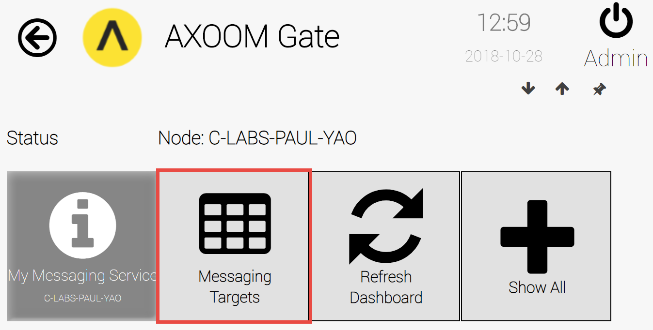 **Figure C.2. The Messaging plugin dashboard.**

1. Click once on the **Refresh** button (), then click on the **Add a new Messaging target** button.

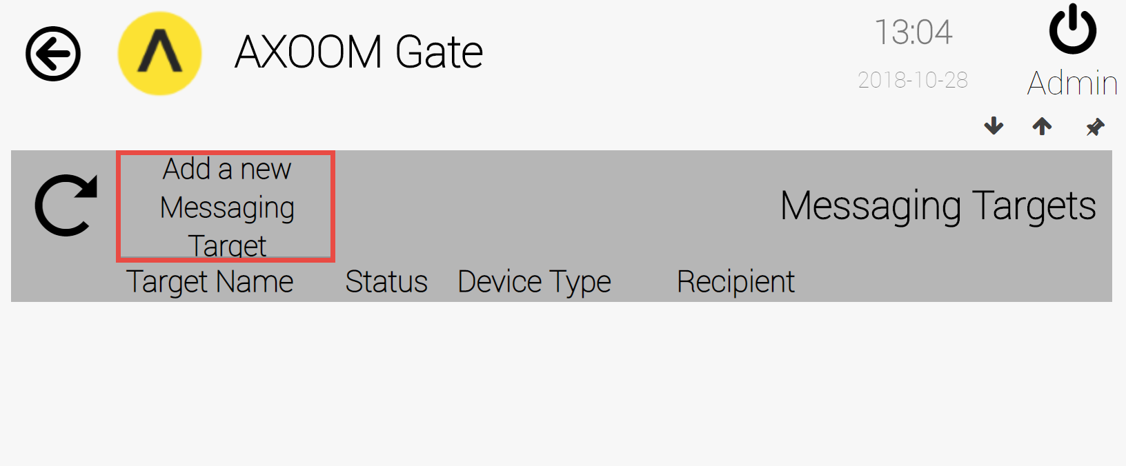  
**Figure C.3. Click Add a New Messaging Target button.**

1. This opens a Messaging Target Table and here you can enter following data:
2. **Target Name**: Define Message Target by giving it a meaningful name.
3. **Status**: This column is output only and will display the status of that target. It will show gray bubble for idle target and green for active target.
4. **Device Type**: Refers to the type of device – in this case it is **Email Message**
5. **Recipient**: Enter email address
6. **Click** on the **Save** button
7. Click on the **Settings** button ()to configure target further:

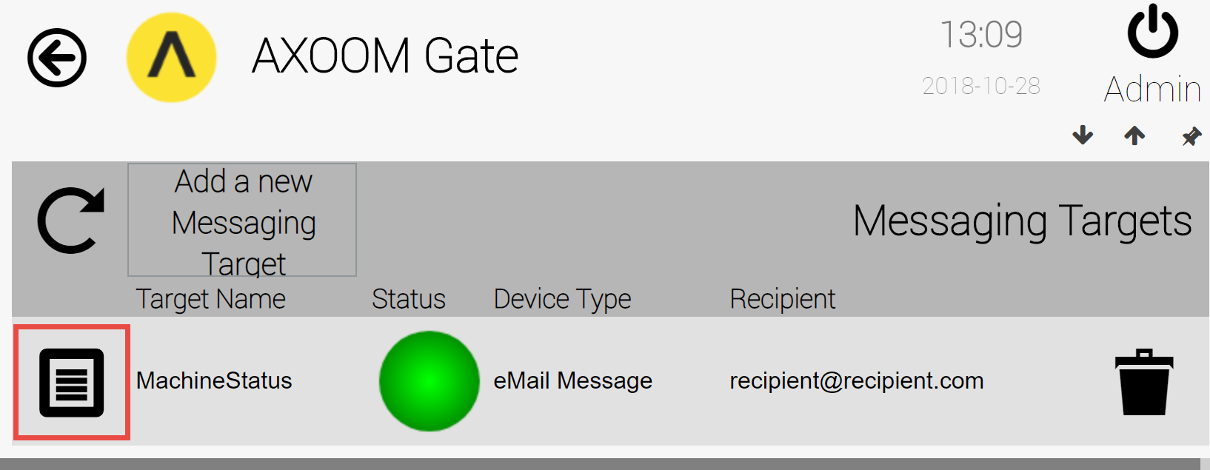  
**Figure C.4. The Messaging Targets table.**

1. This opens a settings form. Enter values all these fields:
2. **From Address**: Email address for sender.
3. **Subject**: Subject line of email messages.
4. **Enter a Recipient**: Email address for recipient.
5. **Enter a message**: Message text. This is for testing purposes, since the text of the message will come from the Rules Engine.
6. Expand the **Additional Settings…** group and fill in the following fields:
7. **Server Name**: The email server name.
8. **UseSSI Checkbox**: Whether to use SSL/TLS for sending the message.
9. **Port**: A port number, likely a value like 25, 2525, 265, or 587.
10. **User Name**: A user name for logging into the email server.
11. **Password:** Password for logging into the email server.
12. **Sent Result:** Status message.
13. **Send Email** button: Click this button to test your email message settings.

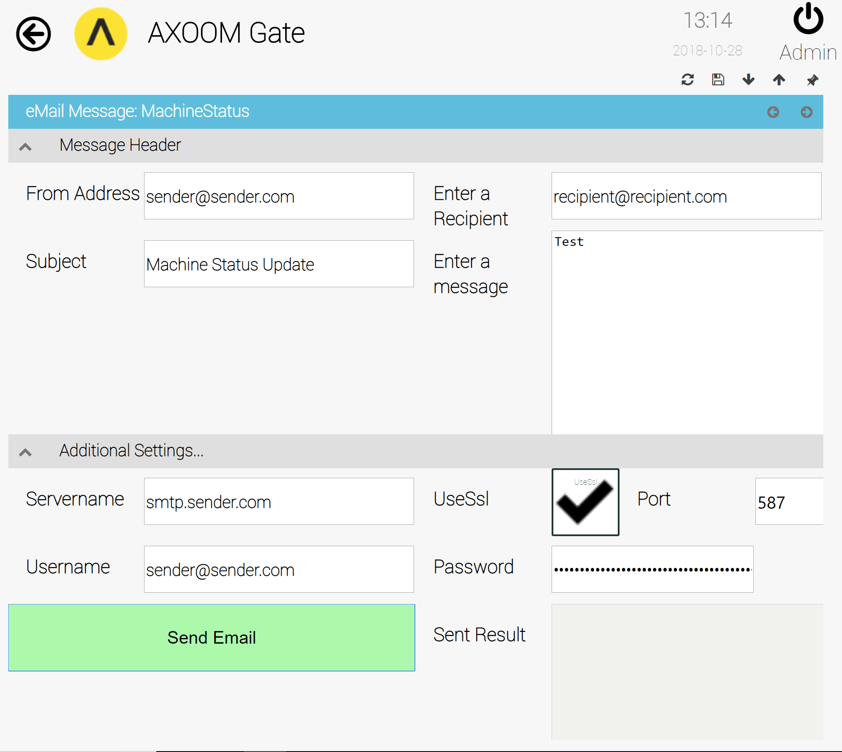  
**Figure C.5. The Send email button**.

For more information on the Messaging Plugin, please see the Messaging Plugin configuration guide.